|  |  |  |
| --- | --- | --- |
| **Qualifications** | **Senators** | **Representatives** |
| **US Citizenship** |  |  |
| **GA Citizenship** |  |  |
| **Resident of his/her district** |  |  |
| **Age** |  |  |
| **Term Length** |  |  |

# The Legislative Branch — The General Assembly

Georgia’s legislative branch is similar to the United States Congress in that it is *_______________*, or has two houses. Georgia’s legislative branch is called the _____________________.

Georgia has had a two house legislature since 1777, when the first state constitution was created. Today those two houses are called the _____________________ and the ___________. The purpose of the General Assembly is to make __________. There are a total of _______ representatives and _____ senators.

 

## The Legislative Process

**Duties:**

Legislative sessions begin in January and last _____________. The House of Representatives can introduce bills designed to _____________________

________________________________________.

The Senate can _____________________________  
________________________________________  
________________________________________.

**Committees: Taxes:**

Summarize what committees do:

**Leadership:**

House of Representatives:

Senate:

f

# The Executive Branch — The Governor, Lt. Governor and Executive Agencies

|  |  |  |
| --- | --- | --- |
| **Qualifications** | **Governor** | **Lt. Governor** |
| **US Citizenship** | _____years | _____years |
| **GA Citizenship** | _____years | _____years |
| **Age** | _____years old | _____years old |
| **Term of office** | _____years (can serve  consecutive terms) | _____years (can serve an unlimited amount of terms) |



The purpose of Georgia’s executive branch is to ____________ the laws. The head of the executive branch is the __________________ and he/she enforces laws when signing a bill into law. The Governor works with the Lt. Governor and Constitutional Officers and Executive Agencies to operate the State of Georgia.

Georgia’s budget allows for spending in seven key areas:

_________________________________________________________________________________________________________________________________and general government. Various agencies in the executive branch are responsible for operating these policy areas.

The governor and lt. governor are elected by ___________________.

The governor can call ______________________

of the General Assembly.

The governor also has the power to __________ bills they don’t agree with.

The ___________________ is next in line to take the governor’s place if the governor cannot finish their term.

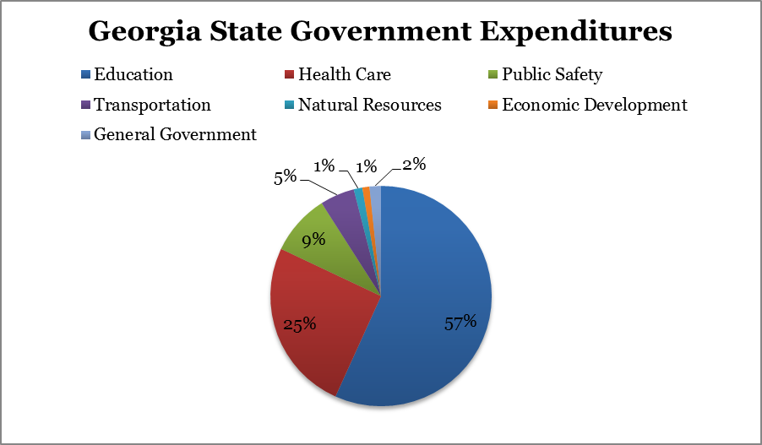

|  |  |
| --- | --- |
| **Court** | **Duties** |
| **Superior**  (Civil and Criminal) |  |
| **State**  (Civil and Criminal) |  |
| **Probate**  (Civil and if there is no state court in the county, criminal) |  |
| **Magistrate** (civil and criminal) |  |
| **Juvenile** |  |
| **Court of Appeals** |  |
| **Supreme Court** |  |

# The Judicial Branch — Georgia’s Court System

Georgia’s Courts fall in one of two categories — *______________________*

*& ______________________.*

Trial courts have original jurisdiction; they are the first court to hear a case.

There are five types of trial courts: State, Juvenile, Probate, Magistrate courts and the most common trial court is the Superior Court. Each county in Georgia is required to have a Superior Court and will hear any civil or criminal case.

Appellate courts review cases that have already been decided by a lower court. The _________________________ and the ______________________ of Georgia each have specific cases they will hear, reexamining past decisions.

Judges for all courts, except the _____________ courts, are elected in non-partisan elections. Judges in courts with original jurisdiction are elected for four year terms; appellate court judges are elected to ______year terms.

**Criminal and Civil Law** Criminal Law —

Civil Law —

Plaintiff —

Defendant —



**Foundations of Government:**

* The symbol for Georgia’s government is the State Seal. It includes four key elements that tell us about our state’s government.
* First, the three columned structure symbolizes our _________ branches of government (legislative, executive and judicial). Second, the columns are connected by the arch (the Georgia ____________) which unifies the three columns (or branches). Next, our state motto, “*___________________________*”, is draped on each column inferring that each branch is described by these one of these words.
* *___________* is associated with the _________________ branch as a quality that the legislators must have in creating new ______ and amending old ones for the state of Georgia.
* *____________*describes the legal system of defending and ______________ the laws of our state. *_______________*refers to the _____________ branch, the office of the governor, as a moderate (or balanced, not extreme) leader for Georgia.
* The current constitution of Georgia was ratified in __________.

**Vocabulary:**

*Constitution –*

*Preamble –*

*Checks and Balances-*

*Separation of Powers –*

*Bill of Rights –*

**Georgia’s Constitution:**

* ***Article I*** *– Bill of Rights*
* ***Article II*** *–*
* ***Article III*** *–*
* ***Article IV*** *– Constitutional Boards & Commissions*
* ***Article V*** *–*
* ***Article VI*** *–*
* ***Article VII*** *– ______________ and Finance*
* ***Article VIII*** *– Education*
* ***Article IX*** *– Counties & Municipal Corporations*
* ***Article X*** *–*
* ***Article XI*** *– Miscellaneous Provisions*