Sherman’s March to the Sea- A Southern Woman’s Perspective
"Oh God, the time of trial has come!"
Dolly Sumner Lunt was born in Maine in 1817. She moved to Georgia as a young woman to join her married sister. She became a school teacher in Covington, Ga. where she met and married Thomas Burge, a plantation owner. When her husband died in 1858, Dolly was left alone to manage the plantation and its slaves. Dolly kept a diary of her experiences and we join her story as Sherman's army approaches her home:
November 19, 1864
Slept in my clothes last night, as I heard that the Yankees went to neighbor Montgomery's on Thursday night at one o'clock, searched his house, drank his wine, and took his money and valuables. As we were not disturbed, I walked after breakfast, with Sadai [the narrator's 9-year-old daughter], up to Mr. Joe Perry's, my nearest neighbor, where the Yankees were yesterday.
Saw Mrs. Laura [Perry] in the road surrounded by her children, seeming to be looking for some one. She said she was looking for her husband, that old Mrs. Perry had just sent her word that the Yankees went to James Perry's the night before, plundered his house, and drove off all his stock, and that she must drive hers into the old fields. Before we were done talking, up came Joe and Jim Perry from their hiding-place. Jim was very much excited. Happening to turn and look behind, as we stood there, I saw some blue-coats coming down the hill. Jim immediately raised his gun, swearing he would kill them anyhow.
'No, don't!' said I, and ran home as fast as I could, with Sadai.
I could hear them cry, 'Halt! Halt!' and their guns went off in quick succession. Oh God, the time of trial has come!
A man passed on his way to Covington. I halloed to him, asking him if he did not know the Yankees were coming.
'No - are they?'
'Yes,' said I; 'they are not three hundred yards from here.'
'Sure enough,' said he. 'Well, I'll not go. I don't want them to get my horse.' And although within hearing of their guns, he would stop and look for them. Blissful ignorance! Not knowing, not hearing, he has not suffered the suspense, the fear, that I have for the past forty-eight hours. I walked to the gate. There they came filing up.
I hastened back to my frightened servants and told them that they had better hide, and then went back to the gate to claim protection and a guard. But like demons they rush in! My yards are full.
To my smoke-house, my dairy, pantry, kitchen, and cellar, like famished wolves they come, breaking locks and whatever is in their way. The thousand pounds of meat in my smoke-house is gone in a twinkling, my flour, my meat, my lard, butter, eggs, pickles of various kinds - both in vinegar and brine - wine, jars, and jugs are all gone. My eighteen fat turkeys, my hens, chickens, and fowls, my young pigs, are shot down in my yard and hunted as if they were rebels themselves. Utterly powerless I ran out and appealed to the guard.
'I cannot help you, Madam; it is orders.'
...Alas! little did I think while trying to save my house from plunder and fire that they were forcing my boys [slaves] from home at the point of the bayonet. One, Newton, jumped into bed in his cabin, and declared himself sick. Another crawled under the floor, - a lame boy he was, - but they pulled him out, placed him on a horse, and drove him off. Mid, poor Mid! The last I saw of him, a man had him going around the garden, looking, as I thought, for my sheep, as he was my shepherd. Jack came crying to me, the big tears coursing down his cheeks, saying they were making him go. I said:
'Stay in my room.'
But a man followed in, cursing him and threatening to shoot him if he did not go; so poor Jack had to yield.
...Sherman himself and a greater portion of his army passed my house that day. All day, as the sad moments rolled on, were they passing not only in front of my house, but from behind; they tore down my garden palings, made a road through my back-yard and lot field, driving their stock and riding through, tearing down my fences and desolating my home - wantonly doing it when there was no necessity for it.
...As night drew its sable curtains around us, the heavens from every point were lit up with flames from burning buildings. Dinnerless and supperless as we were, it was nothing in comparison with the fear of being driven out homeless to the dreary woods. Nothing to eat! I could give my guard no supper, so he left us.
My Heavenly Father alone saved me from the destructive fire. My carriage-house had in it eight bales of cotton, with my carriage, buggy, and harness. On top of the cotton were some carded cotton rolls, a hundred pounds or more. These were thrown out of the blanket in which they were, and a large twist of the rolls taken and set on fire, and thrown into the boat of my carriage, which was close up to the cotton bales. Thanks to my God, the cotton only burned over, and then went out. Shall I ever forget the deliverance?
November 20, 1864.
About ten o'clock they had all passed save one, who came in and wanted coffee made, which was done, and he, too, went on. A few minutes elapsed, and two couriers riding rapidly passed back. Then, presently, more soldiers came by, and this ended the passing of Sherman's army by my place, leaving me poorer by thirty thousand dollars than I was yesterday morning. And a much stronger Rebel!"
References:
This eyewitness account appears in Lunt, Dolly Sumner, A Woman's Wartime Journal, An Account of the Passage Over a Georgia Plantation of Sherman's Army on the March to the Sea, as Recorded in the Diary of Dolly Sumner Lunt (1918); Buel, Clarence, and Robert U. Johnson (eds.), Battles and Leaders of the Civil War, Vol.IV (originally published in Century Magazine, 1888; reprint ed., 1982); Miers, Earl Schenck, The General Who Marched Into Hell (1951)

Sherman’s March to the Sea- A Northern Soldiers Perspective
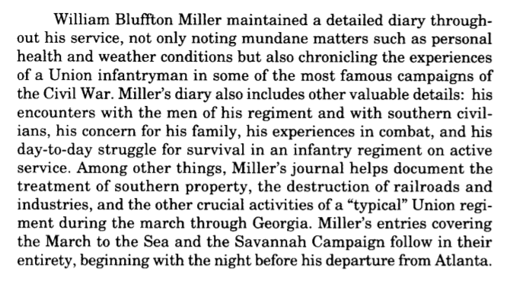
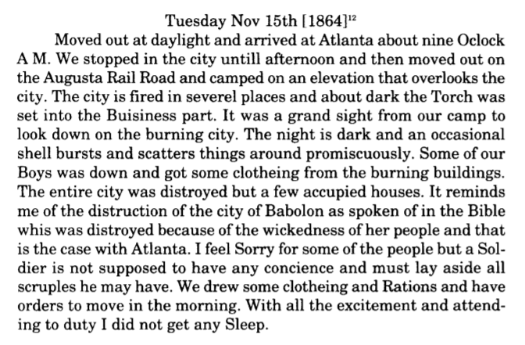

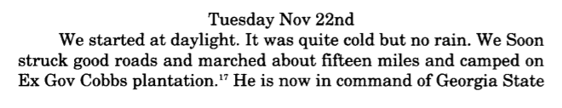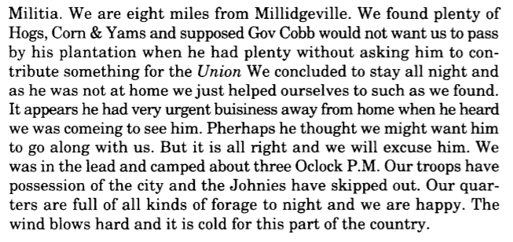
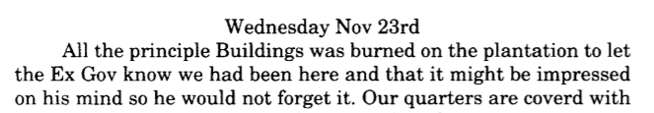
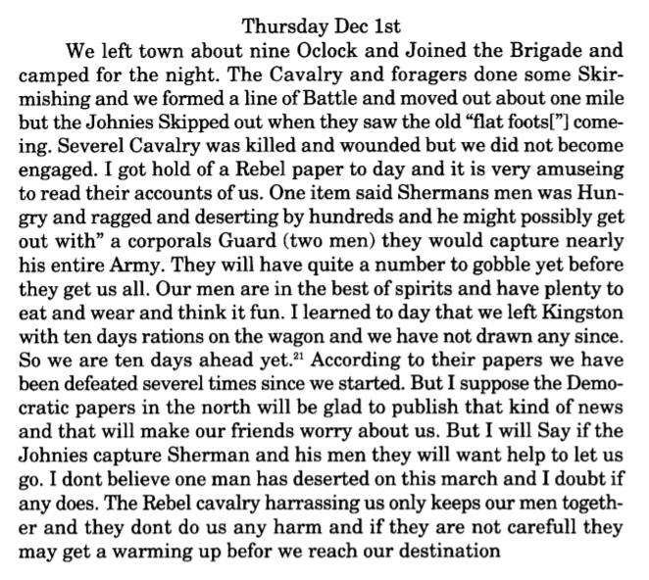
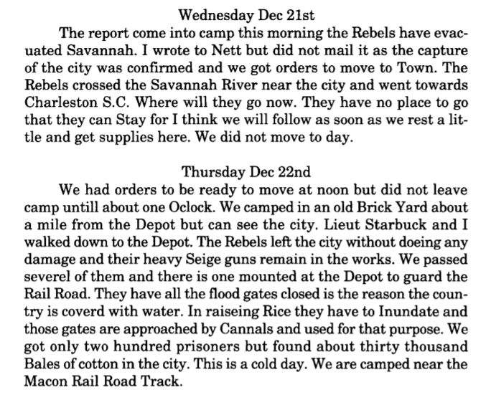

Name: Period:

Sherman’s March to the Sea- A Southern Woman’s Perspective
- What types of supplies did the Union army take from Dolly’s house? Why do you think they would take these things and not leave any for the family that lived there?
_________________________________________________
_________________________________________________
_________________________________________________

- Why do you think the slaves that worked in the house wanted to say with Dolly?
_________________________________________________
_________________________________________________
_________________________________________________

- What type of damage and destruction did Sherman cause on Dolly’s plantation? What was the monetary value of his destruction?
___________________________________________________________________________________________________________________________________________________
- After Sherman and his men had passed why you do think Dolly said she was a “much stronger Rebel”?
___________________________________________________________________________________________________________________________________________________

Sherman’s March to the Sea- A Northern Soldiers Perspective
- What was the city that the Union soldier burned? Why did Miller think that this was a glorious sight?
_________________________________________________
_________________________________________________
_________________________________________________

- Whose plantation did Sherman’s army camp at? What type of damage and destruction did Sherman’s troops cause?
_________________________________________________
_________________________________________________
_________________________________________________

- How did Miller feel the “Rebel paper” was incorrectly representing Sherman’s army? Why did Miller think that “Rebel paper” was describing Sheran’s troops in that way?
__________________________________________________________________________________________________________________________________________________

- What happed to the rebels that were left in Savannah when Sherman arrived? What supplies were they able to find in the city?
_________________________________________________
_________________________________________________
_________________________________________________

Compare and Contrast the Northern and Southern accounts of Sherman’s march using the Venn diagram below

