Personal Budget Portfolio
Name: _________________________________________

Fill in the Following Information:
1. Find your future job possibilities by calculating your GPA on the sheet provided and by researching careers online.
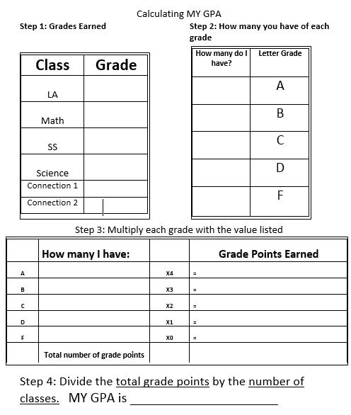
3.5- 4.0 Doctorate (PhD) Degree 2.50 - 2.99 Bachelors Degree 1.0- 1.99 High School
Diploma or GED

3.0- 3.49 Masters Degree 2.0 – 2.49 Associates Degree .99 – 0.0 Did not
complete school
2. Based on you GAP and Education experience choose an entry level job. Record your gross and net income in the spaces provided before. Go to http://www1.salary.com/Entry-Level-Salaries.html to find the starting salary for the career you have chosen.
Based on you GPA choose an entry level career
Job Title: _______________________________________
Gross Income: _____________________________
Below, provide proof of average starting salary in your field. (Copy and paste the link, etc. where you got your information.)
3. How to figure out how much you will pay the federal government in taxes every year (Unmarried individuals):
If Gross Income Is: The Tax Is:
Not over $11,325 10% of the taxable income
Over $11,325 but not over $36,150 $907.50 plus 15% of the excess over $11,325
Over $36,150 but not over $91,600 $5,081.25 plus 25% of the excess over $39,150
Over $91,600 but not over $188,600 $18,193.75 plus 28% of the excess over $91,600
Over $188,600 but not over $407,350 $45,353.75 plus 33% of the excess over $188,600
Over $407,350 but not over $409,000 $117,541.25 plus 35% of the excess over $407,350
Over $409,000 $118,118.75 plus 39.6% of the excess $409,000

Amount of Federal Income Tax Withheld: ______________________________

4. Calculate how much you will pay in State taxes every year by using the web site link:
Georgia collects income taxes from its residents at the following rates.
For single taxpayers:
- first $750 of taxable income = 1% (0.01)
- 2% on taxable income between $751 and $2,250 = 2% (0.02)
- 3% on taxable income between $2,251 and $3,750 = 3% (0.03)
- 4% on taxable income between $3,751 and $5,250 = 4% (0.04)
- 5% on taxable income between $5,251 and $7,000 = 5% (0.05)
- 6% on taxable income exceeding $7,000 = 6% (0.06)
For married people filing joint returns and heads of households, the rates remain the same, but the income brackets cover earnings from $1,000 (at 1%) to $10,000 (at 6%).
(your gross income) x (tax percentage rate in decimal form) =
Amount of State Income Tax Withheld: _____________________________
5. Calculate how much money will be withheld for Social Security and Medicare. When you have wages or self-employment income covered by Social Security, you pay Social Security taxes each year up to a maximum amount set by law. For 2014, you will pay Social Security taxes on income below $117,000. You must pay Medicare taxes based on total income, i.e. there’s no cutoff point. Employers also pay 6.2% SS tax and 1.45% Medicare tax for each employee on the payroll. This means you pay half of this tax out of your wages and the employer pays the other half.
Also, beginning in 2013 you must pay 0.9 percent more in Medicare taxes on earned individual income of more than $200,000. The tax rates shown below do not include the 0.9 percent:
- Employees — the Social Security tax rate is 6.2 percent on income under $117,000 starting January 1, 2014.
(your gross income) x 0.062 =
Amount of Social Security Tax Withheld: ____________________________
- The Medicare tax rate is 1.45 percent of total income.
(your gross income) x 0.0145 =
Amount of Medicare Tax Withheld: ___________________________
6. Calculate 10% of gross for a personal retirement account.
(your gross income) x 0.10 =
Amount of Retirement deduction: _______________
7. Net income, or what is commonly referred to as take home pay, is figured by subtracting all of the deductions that will be taken out of your paycheck. Standard deductions include FICA (Social Security and Medicare), but may also include health insurance, personal retirement plans, union dues, just to name a few. Complete steps 3 through 5 by following the instructions provided in each step and by using gross income as the starting point when figuring each deduction.
***Use the chart below to subtract the sum of steps 3 through 7 from your gross income to calculate your net income (actual take-home pay). Write the net income below.
Your Gross Income | $
Federal Income Tax | - $
State Income Tax | - $
Social Security Tax | - $
Medicare Tax | - $
Retirement | - $
Your Net Income

Net Income: ___________________________

8. Take your net income and divide it by 12 to find out how much you will have in your paycheck every month.
(net income) ÷ 12 =
Take Home Pay: _______________________________
NOW YOU START PAYING BILLS!
9. Calculate how much money you will pay for healthcare insurance. Assume that your employer will be providing coverage. Use the link provided to find a healthcare plan that suits you. Decide on a healthcare plan and deduct the cost from your take
home pay. http://dch.georgia.gov/sites/dch.georgia.gov/files/42578_Active-2016-9.21.16.pdf
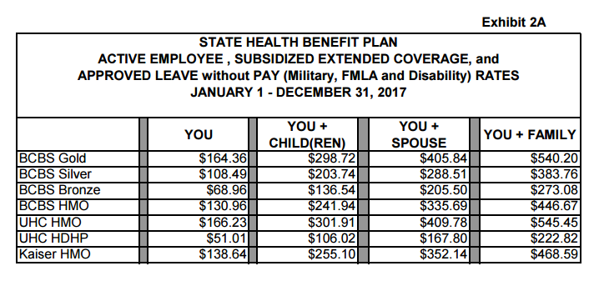
Monthly Health Insurance Payment: _________________________________
10. Calculate how much student debt you will have to pay per month.
To do this you will first need to know how much debt the average student with your degree accumulates. Now go to the following link to calculate what the schedule is for paying back your student debt in 10 years: http://www.amortizationtable.org/
Degree | Amount of Debt | Monthly Payment
Doctorate Degree | $100,000.00 | $790.79
Masters Degree | $50,000.00 | $395.40
Bachelors Degree | $30,000.00 | $237.24
Associates Degree | $15,000.00 | $118.62
High School Diploma | $0 | $0
Did not complete school | $0 | $0

Monthly Student Loan Payment: ____________________________________
11. You have to find an apartment. You will be renting on your own. Choose from one of the following apartments. Monthly utilities are listed beneath each apartment and will needed to be included in your costs.
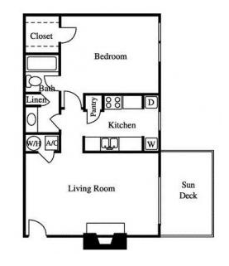 | 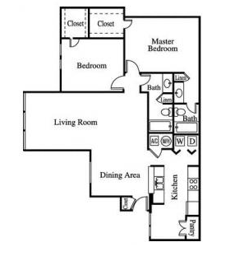 | 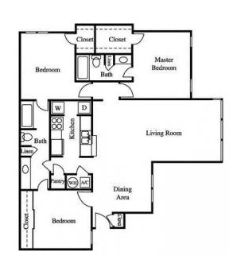
1 bedroom 1 bath  688 sq. ft. | 2 bedroom 2 bath  1253 sq. ft. | 3 bedroom 2 bath  1254 sq. ft.
$925/month | $1,125/month | $1,525/month
$75/month | $125/month | $150/month

Monthly rent: ___________________ + monthly utilities __________________

12. Purchase a car. Look through cars below and choose from the following 4 optio You will have to finance this purchase and should expect to take out a 5-year (60 month) loan. Typically, you can expect to give 20% down on the purchase if you don’t have established credit. You will also need car insurance in case of an accident. The bigger, newer, and more expensive your car is the more your insurance will cost per month.
 |  |  | 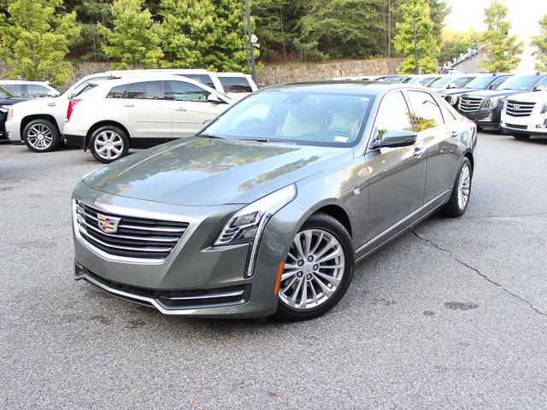
2012 Honda Civic  60,000 miles | 2013 Jeep Cherokee  23,000 miles | 2017 GMC Acadia Denali  O miles | 2017 Cadillac CT6  O miles
$13,998 | $22,998 | $47,985 | $43,435
$238.53/month | $384.30/month | $799.68/month | $706.44/month
$100/month | $250/month | $3500/month | $400/month

Monthly Car Payment: ________________+ Monthly Car Insurance Payment: ____________

13. You need to get a phone plan and find a cable and Internet plan.
Monthly Phone Payment: ______________________ and provider: and provider:
Verizon: https://www.verizonwireless.com/plans/verizon-plan/
AT&T: https://www.att.com/plans/unlimited-data-plans.html
Monthly Cable and Internet Payment: _______________________
Comcast: https://www.xfinity.com/cable-internet-packages.html
AT&T/DirectTV: https://www.att.com/bundles/
16. Create an actual shopping list of groceries you will consume in one week. You will have to find real prices for everything and fill in the form below as proof of your expenses.
Kroger: https://www.kroger.com/
Publix: http://www.publix.com/
Name of Grocery Store You Will Shop At: _________________________________
Food Item | Quantity | Price | Total Cost

Weekly Grocery Bill ________________________X 4 = __________________________

17. Now that you have finished all of the calculations, create an accounting ledger to show monthly income and expenses.
Description | Deposit (Add) | Withdrawal (Subtract) | Balance
Take Home Pay | $
Health Insurance
Rent Payment
Utilities
Car Payment
Car Insurance
Cell Phone
Cable and Internet
Grocery Bill

How much is left after all expenses? _____________________________

