Georgia Studies
Modern Georgia (SS8H12)
Name: ___________________ Date: __________ Period: _____
Maynard Jackson
- In 1973, Maynard Jackson made history when he was elected as __________________________________________________ .
- As mayor, Jackson made sure that minority businesses received a __________________________________________________ , often upsetting established white business owners.
- Under his leadership, MARTA (Atlanta’s mass transit system) began running and Hartsfield Airport added a new __________________________________________________ .
- The city of Atlanta added his name to the airport in 2003: _________________________________________ .
Andrew Young
- Andrew Young became well known as a civil rights activist and __________________________________________________ .
- In 1972, he won a seat in Congress and was Georgia’s __________________________________________________ to the House since Reconstruction.
- In 1977, President Carter appointed Young to be America’s __________________________________________________ .
- In 1981, he succeeded Jackson as ________________________________________ .
- Young served two successful terms as mayor where he increased international investment in the city and brought the __________________________________________________ to Georgia.
- He __________________________________________________ in 1990, but lost to Zell Miller.
- Young played a key role in bringing the __________________________________________________ to Atlanta.
Atlanta 1996
- In 1996, Atlanta hosted the _____________________________________ .
- The festivities not only honored the _____________________________________ of the modern Olympics but also brought recognition and investment to Georgia from all over the world.
- With the opening of the Games, Atlanta welcomed _____________________________________ , as well as countless spectators to the city.
- Existing _____________________________________ and additional venues were constructed not only throughout the city, but also throughout the state and other surrounding states.
- Downtown Atlanta was revamped with new sidewalks, trees, and lights, and the _____________________________________ was developed in the heart of the city.
- The Olympic Stadium became the _________________________________________________ .
- _____________________________________ were built for Olympic athletes and are now used by state universities.

Impact
- The city of Atlanta and the entire state of Georgia _____________________________________ from hosting the Olympics.
- The estimated impact of the Olympics on Atlanta was over _____________________________________ , and much of Georgia’s economic fortune today is a result of the Centennial Olympic games.
- The Olympics also established Atlanta’s reputation as a excellent place for ___________________________________ .
Benefits
- _____________________________________ were created throughout the state for the Olympics.
- The government increased its _____________________________________ , which was then spent on providing services and programs for Georgia’s citizens.
- Since the Olympics, many _____________________________________ to Georgia to take advantage of Atlanta being in international city.

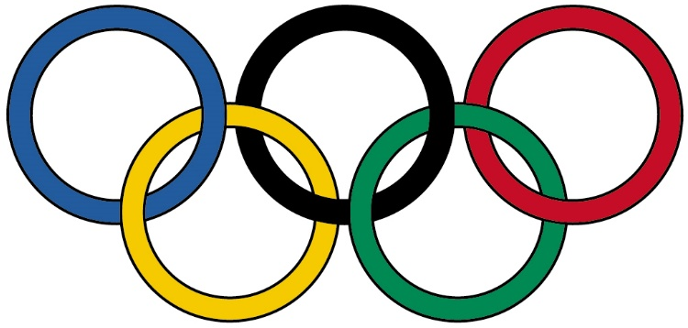
Immigrants
- Georgia’s _____________________________________________ since the 1990s, partly due to new immigrant communities within the state.
- Georgia’s foreign-born population has increased from 1990 to 2000 by ______________________ .
- More than 50% of Georgia’s immigrants came from ___________________________________________________.
Impact
- Legal immigrant communities provide _____________________________________ , particularly in northern Georgia’s construction, _____________________________________ , and carpet manufacturing industries.
- This helps businesses grow while providing _____________________________________ for consumers.
- New immigrant communities also increase the _____________________________________ of an area.

Tourism
- Tourism is one of Georgia’s _____________________________________________
- Popular destinations include ______________________ .
- Tourism as become ___________________________________________________ and .
Savannah harbor
- Savannah’s port is the busiest port and the fastest growing port in the US.
- The project is now underway, which will deepen the harbor _____________________________________.
- The new locks will accommodate ships _____________________________________.
- The new expansion will allow for more _____________________________________ .
Film Industry
- Georgia has a rapidly growing film industry that _____________________________________________
- This is due to ______________________ .
- The climate allows for __________________________________________________ and the airport allows for .
- The film industry creates and supports several arts colleges in the state.
- Georgia is also home to , both produce movies and television shows.
- Is also headquartered in Atlanta and is a .

Jimmy Carter

Early Life
- James Earl Carter, Jr. was born on _________________________________________ in Plains, Georgia.
- Carter had a _________________________________________ , but returned home to Plains after his father passed away.
- Jimmy, his wife Rosalynn, and their four kids managed the _________________________________________ .
Senator
- Carter began his political career in 1962 when he won the _________________________________________ for the 14th District of Georgia.
- He _________________________________________ in the State Senate and promoted the need for reorganizing Georgia’s system while in office.
Governor
- In 1970, Jimmy Carter _________________________________________ and quickly began to create a “new Georgia”.
- In his inaugural address, he informed Georgians that it was time for _________________________________________ .
- Carter favored integration and often butted heads with his lieutenant governor, Lester Maddox, over _________________________________________ .
- Carter used his four years in office to restructure the _________________________________________ and completely change the format of the state budget.
- He also pushed for _________________________________________ , mental health, and criminal justice systems.
- Carter also favored _________________________________________ in Georgia.
President
- In the 1976 election, Carter defeated incumbent Republican President Gerald Ford to become the _________________________________________ .
- President Carter _________________________________________ and created several new programs and departments that are still a fundamental part of the federal government today.
Camp David Accords
- For centuries, Arabs and Jews have fought over _________________________________________ .
- President Carter invited Egypt’s president and Israel’s prime minister to Camp David (the president’s personal retreat) to try to _________________________________________ .
- On September 17, 1978, the leaders negotiated a peace treaty and signed the _________________________________________ .
- Many saw this as a _________________________________________ and Carter was given credit for his role in negotiating the agreement.

Soviets
- After Carter exercised his foreign policy in the Middle East, he established the SALT II nuclear limitation treaty with the Soviet Union which limited the number of ________________________________________________________ .
- Not long after agreeing to the terms, the _________________________________________ and invaded Afghanistan.
- President Carter responded with a _____________________________ and a boycott of the 1980 Olympic Games in Moscow; however, many Americans questioned whether he was capable of being _________________________________________ .
Iran Hostage Crisis
- Even more ________________________________________________________ was the Iran Hostage Crisis.
- In 1979, Iranian students ________________________________________________________ in Tehran and took those inside hostage.
- The students were angry at Carter for allowing Iran’s former leader to enter the US for _________________________________________ .
- They demanded the Shah be returned to Iran in _________________________________________ .
- Carter _________________________________________ and the crisis continued.
- Five months later, Carter authorized a ________________________________________________________ when a military helicopter crashed into a transport plane, killing several US soldiers.
- Americans were ________________________________________________________ for not taking better control of the event.
- When Carter lost the 1980 election, the Iranians agreed to _________________________________________ .
Post-Presidency
- While his approval ratings may not have been high as president, Carter has become one of the ________________________________________________________ .
- Carter has worked to ________________________________________________________ around the world, and has often been called on to represent the US in diplomatic efforts.
- He built the _________________________________________ in 1982, and it works to fight diseases and starvation throughout the world.
- The Center has also monitored over _________________________________________ to ensure fair and balanced results and provided additional assistance to the democratic process.
Nobel Prize
- For his dedication to humanitarian efforts and ending international conflict, Carter was awarded the _________________________________________ .
- The award is given to the person whose work has _________________________________________ .

