Georgia Milestones Study Guide Name: _______________________ Date: ________ Period: ____
Georgia’s Location:
Region: __________________ Nation: ________________
Continent: ____________Hemisphere: ________________
Describe the five geographic regions of Georgia:
1. Blue Ridge Mountains: ___________________________________________________________________
2. Valley and Ridge: _______________________________________________________________________
3. Appalachian Plateau: _____________________________________________________________________
4. Piedmont: ______________________________________________________________________________
5. Coastal Plain: ___________________________________________________________________________
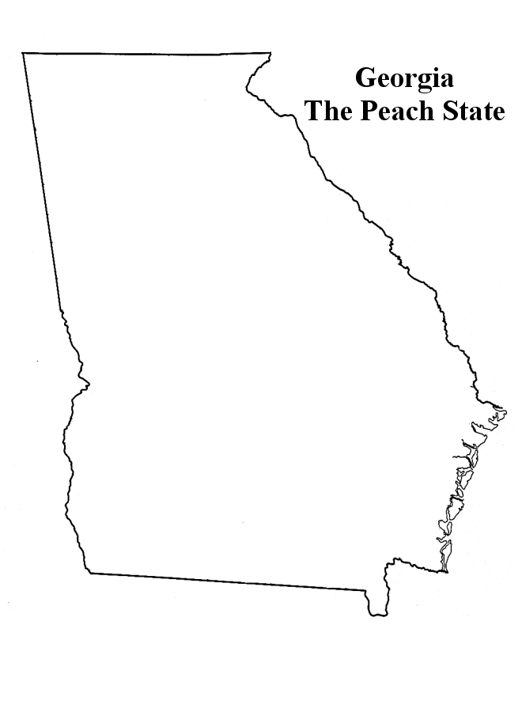

Draw and label the five geographic regions of Georgia:

Locate and evaluate the importance of key physical features on the development of Georgia:
1. Fall Line: ___________________________________________________________________________________
2. Okefenokee Swamp: __________________________________________________________________________
3. Appalachian Mountains: _______________________________________________________________________
4. Chattahoochee River: __________________________________________________________________________
5. Savannah Rivers: _____________________________________________________________________________
6. barrier islands: _______________________________________________________________________________

How has climate impacted on Georgia’s development through different eras: (Agriculture, Slavery, cotton, etc)
__________________________________________________________________________________________________________________________________________________________________________________________

Explain how the following transportation systems contribute to the state’s economy:
1. Interstate Highway: ___________________________________________________________________________
_____________________________________________________________________________________________
2. Hartsfield-Jackson International Airport: __________________________________________________________
_____________________________________________________________________________________________
3. Georgia’s deepwater ports: _____________________________________________________________________
_____________________________________________________________________________________________

What was the impact of European contact on Native American cultures:___________________________________
_____________________________________________________________________________________________
A. Spanish missions along the barrier islands: ________________________________________________________
_____________________________________________________________________________________________
B. Explorations of Hernando DeSoto (1539-1542):____________________________________________________
_____________________________________________________________________________________________

Explain reasons for European exploration and settlement of North America in the southeastern area: (e.g. trade, commerce, religious freedom, gold, spread Christianity, etc.)
1. French: ____________________________________________________________________________________
2. Spanish: ____________________________________________________________________________________
3. British: _____________________________________________________________________________________

Georgia’s Colonial Period Explain the importance of the following people, events, or places:
1. James Oglethorpe: ____________________________________________________________________________
2. Charter of 1732:______________________________________________________________________________
3. Reasons for settlement:
1. philanthropy (charity) -
2. economics-
3. defense-
4. Tomochichi: _________________________________________________________________________________
5. Mary Musgrove: _____________________________________________________________________________
6. City of Savannah: ____________________________________________________________________________

Trustee Period of Georgia’s Colonial history (1732-1752) Discuss the importance of the following:
1. Salzburgers: _________________________________________________________________________________
2. Highland Scots: ______________________________________________________________________________
3. malcontents: _________________________________________________________________________________
4. Spanish threat from Florida (Jenkins Ear)__________________________________________________________
Royal Colonial Period (1752-1776) Describe the Royal Colonial Period in regards to the following:
1. land ownership- _____________________________________________________________________________
2. slavery- ____________________________________________________________________________________
3. government- ________________________________________________________________________________
4. Impact of the royal governors- __________________________________________________________________
_____________________________________________________________________________________________

Georgia in the American Revolution.
Explain the immediate and long-term causes of the American Revolution and their impact on Georgia:
1. French and Indian War (i.e., Seven Years War): _____________________________________________________
_____________________________________________________________________________________________
2. Proclamation of 1763: _________________________________________________________________________
_____________________________________________________________________________________________
3. Stamp Act: _________________________________________________________________________________
_____________________________________________________________________________________________
4. Intolerable Acts (response to Boston Tea Party): ____________________________________________________
_____________________________________________________________________________________________
5. Declaration of Independence (July 4th 1776): _______________________________________________________
_____________________________________________________________________________________________

Key People and Events in Revolutionary War in Georgia
1. Loyalists: ___________________________________________________________________________________
2. Patriots: ____________________________________________________________________________________
3. Elijah Clarke: ________________________________________________________________________________
4. Austin Dabney: ______________________________________________________________________________
5. Nancy Hart: ________________________________________________________________________________
6. Button Gwinnett, Lyman Hall, George Walton: ____________________________________________________
7. Battle of Kettle Creek: ________________________________________________________________________
8. Siege of Savannah: ___________________________________________________________________________

Describe the impact of events that led to the ratification of the United States Constitution and the Bill of Rights:
Define the following:

Constitution: _______________________________________________________________________________________
Ratify: ____________________________________________________________________________________________
Bill of Rights: _______________________________________________________________________________________
Bicameral and Unicameral legislature: ___________________________________________________________________

Articles of Confederation
Strengths | Weaknesses

Why did we have to revise the Articles and create the U.S. Constitution?
__________________________________________________________________________________________________________________________________________________________________________________________

Describe the role of Georgia at the Constitutional Convention of 1787: ____________________________________
__________________________________________________________________________________________________________________________________________________________________________________________

What was the role of Abraham Baldwin and William Few: ______________________________________________
_____________________________________________________________________________________________

Reasons why Georgia ratified the new constitution: ___________________________________________________
__________________________________________________________________________________________________
Georgia post Constitution 1789 to 1840. Explain the significance of the following:
1. University of Georgia: _________________________________________________________________________
2. Louisville: __________________________________________________________________________________

Evaluate the impact of land policies pursued by Georgia: (1790’s-early 1800’s)
1. Headright system: ____________________________________________________________________________
_____________________________________________________________________________________________
2. land lotteries:________________________________________________________________________________
3. Yazoo land fraud: ____________________________________________________________________________
_____________________________________________________________________________________________

Explain how technological developments impacted GA’s Growth at this time:
1. Cotton gin: __________________________________________________________________________________
2. Railroads: __________________________________________________________________________________

INDIAN REMOVAL - Analyze the events that led to the removal of Creeks and Cherokees:
1. Alexander McGillivray:________________________________________________________________________
_____________________________________________________________________________________________
2. William McIntosh: ___________________________________________________________________________
_____________________________________________________________________________________________
3. Sequoyah: __________________________________________________________________________________
_____________________________________________________________________________________________
4. John Ross: __________________________________________________________________________________
_____________________________________________________________________________________________
5. Dahlonega Gold Rush: _________________________________________________________________________
_____________________________________________________________________________________________
6. Worcester v. Georgia: (Samuel Worcester) ________________________________________________________
_____________________________________________________________________________________________
7. Andrew Jackson: (Indian Removal Act)___________________________________________________________
8. John Marshall: ______________________________________________________________________________
9. Trail of Tears: ______________________________________________________________________________

CIVIL WAR 1861-1865 -Explain the importance of key events that led to the Civil War:
1. Slavery: ____________________________________________________________________________________
_____________________________________________________________________________________________
2. states’ rights: ________________________________________________________________________________
_____________________________________________________________________________________________
3. nullification: _________________________________________________________________________________
4. Missouri Compromise: ________________________________________________________________________
_____________________________________________________________________________________________
5. Compromise of 1850: _________________________________________________________________________
_____________________________________________________________________________________________
6. Georgia Platform: ____________________________________________________________________________
7. Kansas-Nebraska Act(1854): ____________________________________________________________________
_____________________________________________________________________________________________
8. Dred Scott case: ______________________________________________________________________________
_____________________________________________________________________________________________
9. Election of 1860: (Abraham Lincoln) _____________________________________________________________
_____________________________________________________________________________________________
10. The debate over secession in Georgia and the role of Alexander Stephens: ______________________________
_____________________________________________________________________________________________

State the importance of key events of the Civil War- Key Battles and Events
1. Antietam: __________________________________________________________________________________
2. Emancipation Proclamation: ____________________________________________________________________
_____________________________________________________________________________________________
3. Gettysburg:__________________________________________________________________________________
4. Chickamauga: _______________________________________________________________________________
_____________________________________________________________________________________________
5. Union blockade of Georgia’s coast: ______________________________________________________________
_____________________________________________________________________________________________
6. Sherman’s Atlanta Campaign: __________________________________________________________________
_____________________________________________________________________________________________
7. Sherman’s March to the Sea: ____________________________________________________________________
_____________________________________________________________________________________________
8. Andersonville: _______________________________________________________________________________
_____________________________________________________________________________________________

Analyze the impact of Reconstruction on Georgia and other southern states
1. Freedmen’s Bureau: __________________________________________________________________________
_____________________________________________________________________________________________
2. sharecropping: _______________________________________________________________________________
_____________________________________________________________________________________________
3. tenant farming: _______________________________________________________________________________
_____________________________________________________________________________________________
4. Lincoln’s Reconstruction plans: _________________________________________________________________
_____________________________________________________________________________________________
5. Republican’s Reconstruction Plans: ______________________________________________________________
_____________________________________________________________________________________________
6. 13th Amendment: ____________________________________________________________________________
7.14th Amendment: _____________________________________________________________________________
8. 15th amendment: _____________________________________________________________________________
9. Henry McNeal Turner: ________________________________________________________________________
10. Ku Klux Klan: _____________________________________________________________________________
_____________________________________________________________________________________________

THE NEW SOUTH - Evaluate key political, social, and economic changes that occurred in Georgia between 1877 and 1918.
1. Bourbon Triumvirate: _________________________________________________________________________
_____________________________________________________________________________________________
2. Henry Grady: ________________________________________________________________________________
_____________________________________________________________________________________________
3. International Cotton Exposition: _________________________________________________________________
_____________________________________________________________________________________________
4. Tom Watson and the Populists Party: _____________________________________________________________
_____________________________________________________________________________________________
5. 1906 Atlanta Riot_____________________________________________________________________________
_____________________________________________________________________________________________ 6. Leo Frank Case: _____________________________________________________________________________
_____________________________________________________________________________________________

Early Civil Rights Movement- Analyze how rights were denied to African-Americans
1. Jim Crow laws: ______________________________________________________________________________
_____________________________________________________________________________________________
2. Plessy v. Ferguson: ___________________________________________________________________________
_____________________________________________________________________________________________
3. disenfranchisement: ___________________________________________________________________________
_____________________________________________________________________________________________
4. racial violence: ______________________________________________________________________________
_____________________________________________________________________________________________
5. Booker T. Washington: ________________________________________________________________________
_____________________________________________________________________________________________6. W. E. B. DuBois: ____________________________________________________________________________
_____________________________________________________________________________________________ 7. John and Lugenia Burns Hope: __________________________________________________________________
_____________________________________________________________________________________________
8. Alonzo Herndon: ____________________________________________________________________________
_____________________________________________________________________________________________

WWI and Georgia
1. Why did WWI take place: _____________________________________________________________________________________________
_____________________________________________________________________________________________
2. How did the U.S. get involved in WWI:__________________________________________________________
_____________________________________________________________________________________________
2. Describe Georgia’s contributions: ________________________________________________________________
_____________________________________________________________________________________________
Event that occurred after World War I and their impact on Georgia.
Describe the impact of the boll weevil and drought on Georgia: __________________________________________
_____________________________________________________________________________________________

Explain economic factors that resulted in the Great Depression:
1. _____________________________2. ___________________________3. _____________________________
4.______________________ 5. _____________________6. _____________________

Discuss the political career of Eugene Talmadge: _____________________________________________________
_____________________________________________________________________________________________

Discuss the effect of the New Deal
What was the New Deal? _______________________________________________________________________
1. Civilian Conservation Corps: ___________________________________________________________________
2. Agricultural Adjustment Act: ___________________________________________________________________
3. Rural Electrification Act : ______________________________________________________________________
4. Social Security: ______________________________________________________________________________

World War II
What led the US into World War II? ____________________________________________________________________
1. Lend-Lease Act: _____________________________________________________________________________
2. Pearl Harbor: ________________________________________________________________________________

Georgia Contributions in WWII
1. Bell Aircraft Factory: _________________________________________________________________________
2. military bases: _______________________________________________________________________________
3. Savannah and Brunswick shipyards: ______________________________________________________________
_____________________________________________________________________________________________
4. Richard Russell: ______________________________________________________________________________
_____________________________________________________________________________________________
5. Carl Vinson: ________________________________________________________________________________

Discuss the ties to Georgia that President Roosevelt had and his impact on the state: _________________________
_____________________________________________________________________________________________

Post-World War II developments of Georgia from 1945 to 1970.
Analyze the impact of the transformation of agriculture on Georgia’s growth: ______________________________
_____________________________________________________________________________________________

Explain the development of Atlanta
William B. Hartsfield: ___________________________________________________________________________ Ivan Allen, Jr. and major league sports: _____________________________________________________________
_____________________________________________________________________________________________
Discuss the impact of Ellis Arnall: ________________________________________________________________
_____________________________________________________________________________________________

Civil Rights Movement
1946 governor’s race:

End of the white primary:

Brown v. Board of Education:

Martin Luther King, Jr.:

1956 state flag:

Student Nonviolent Coordinating Committee (SNCC):

Sibley Commission:

Albany Movement:

March on Washington:

Civil Rights Act of 1964:

Maynard Jackson as mayor of Atlanta:

Lester Maddox:

Andrew Young :

Georgia since 1970.

Describe the role of Jimmy Carter in Georgia as state senator, governor, president, and past president:

Evaluate the effect of the 1996 Olympic Games on Georgia:

Evaluate the importance of new immigrant communities to the growth and economy of Georgia:

The student will evaluate the influence of Georgia’s economic growth and development

Define profit and describe how profit is an incentive for entrepreneurs:

Explain how entrepreneurs take risks to develop new goods and services to start a business:

Evaluate the importance of entrepreneurs in Georgia who developed such enterprises as Coca-Cola, Delta Airlines, Georgia-Pacific, and Home Depot. What have these companies done for GA?

