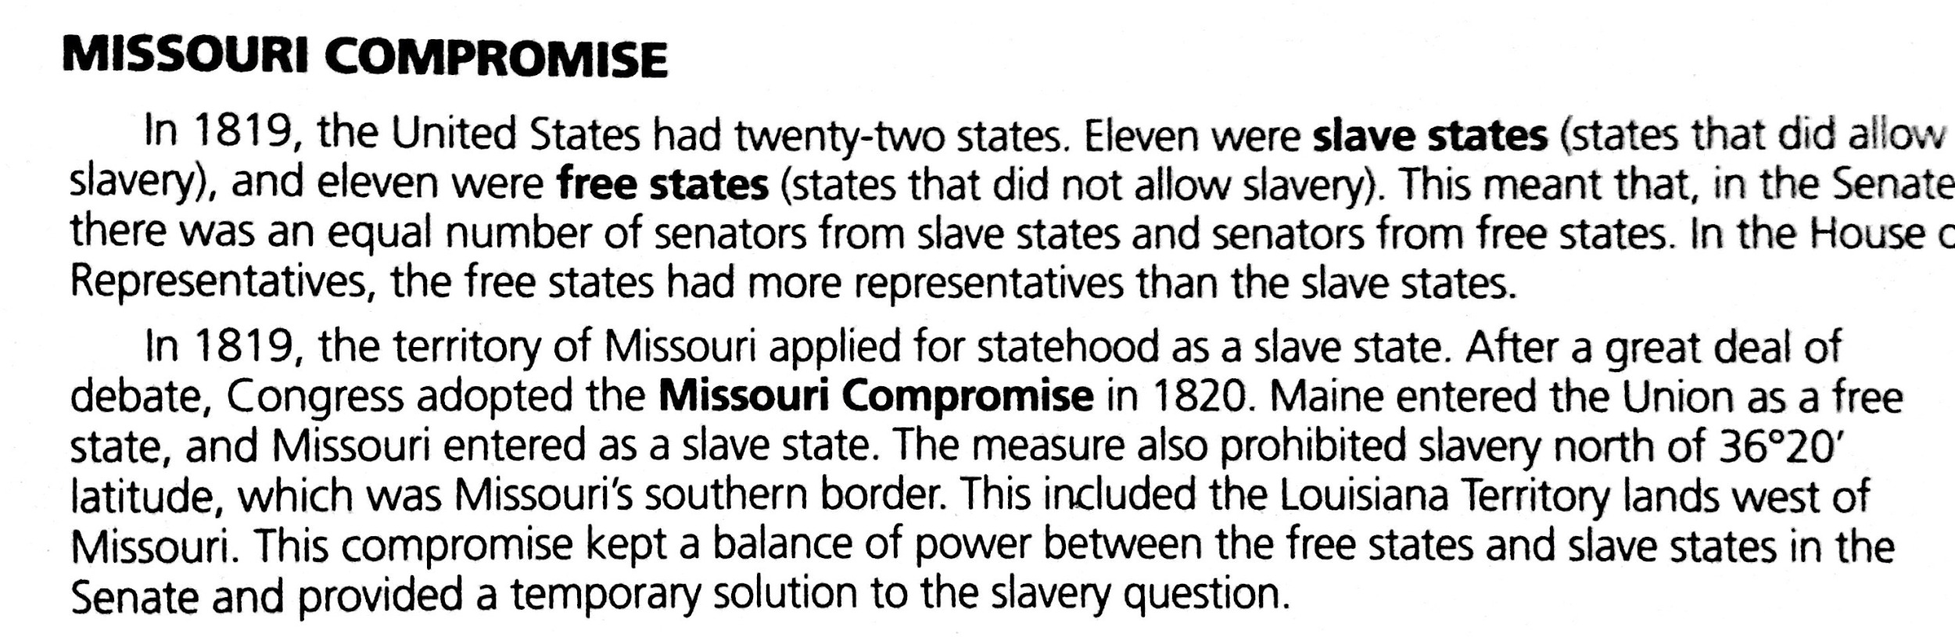

What did the Missouri Compromise prohibit?

What was the outcome of the Missouri Compromise?

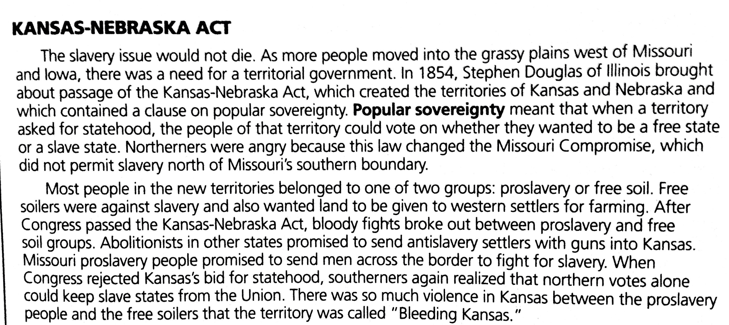

Why were Northerners angry about the Kansas-Nebraska Act?
What happened in Kansas?

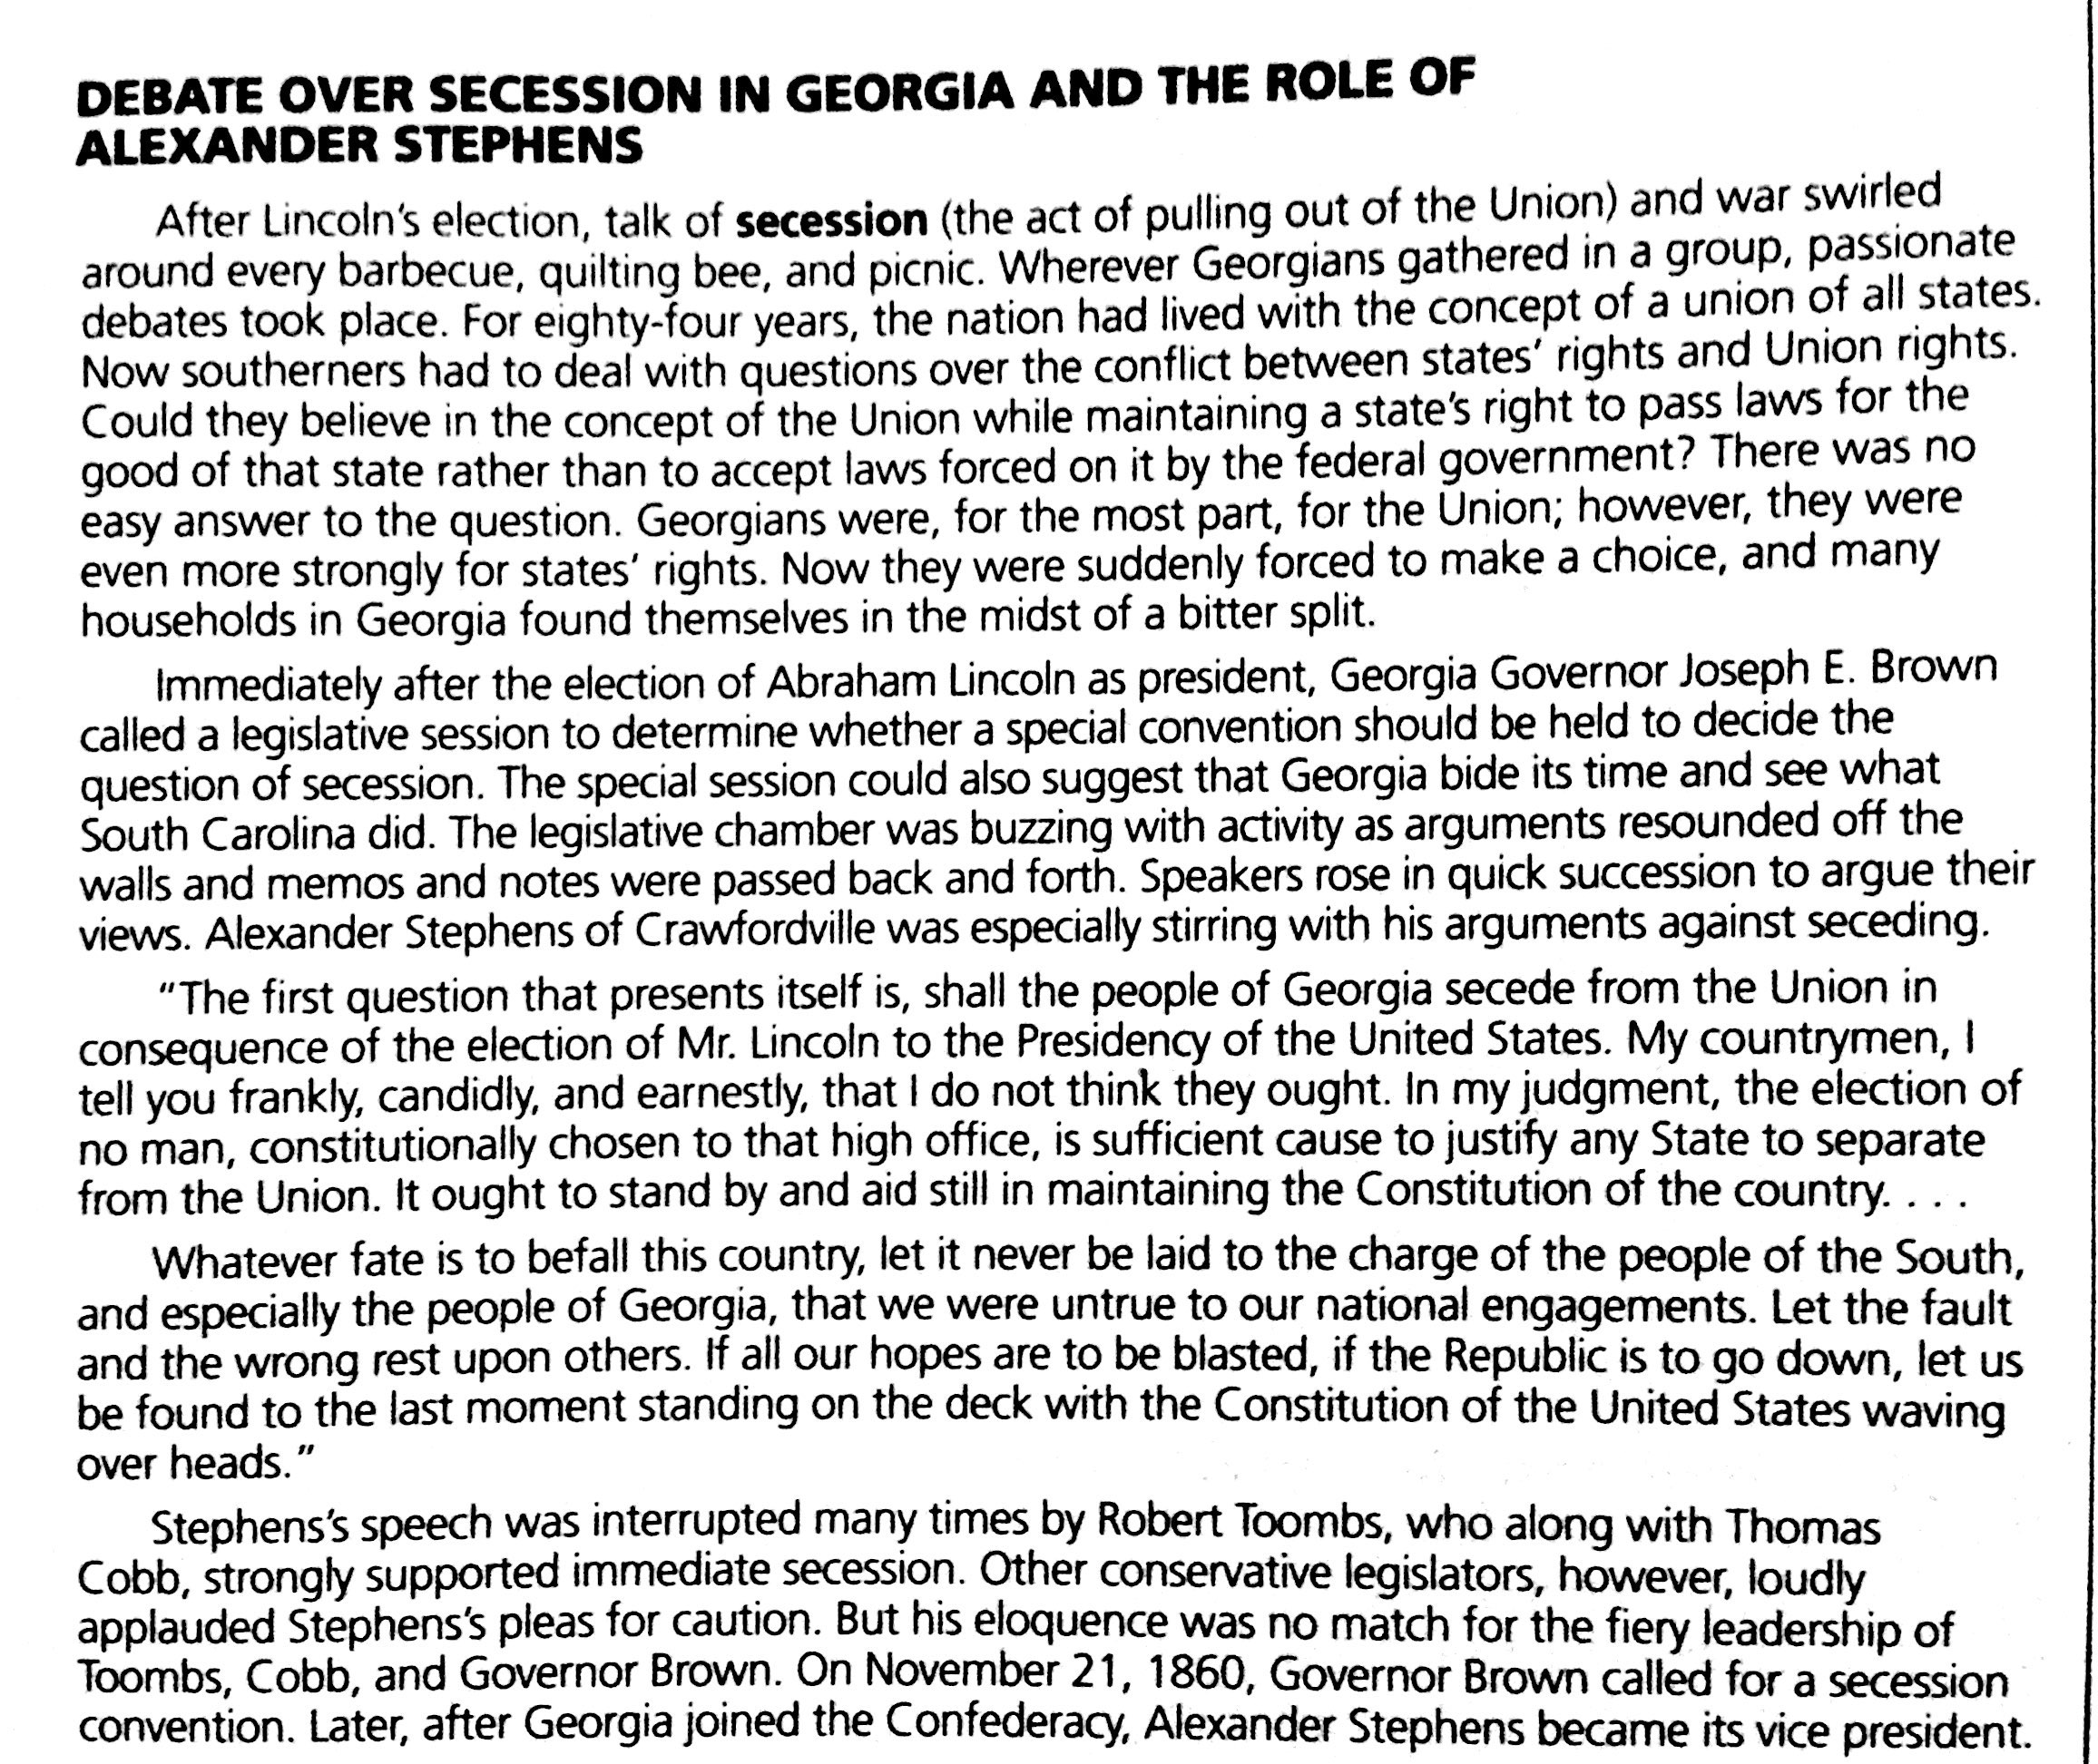

What made some Georgians want to secede from the Union?

What was Alexander Stephens’ view of seceding?

