Milestones Reviews #24-26

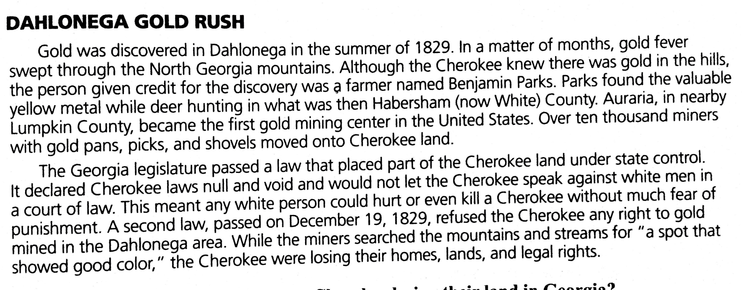

Where was gold first discovered in Georgia?

How were rights taken away from the Cherokee?

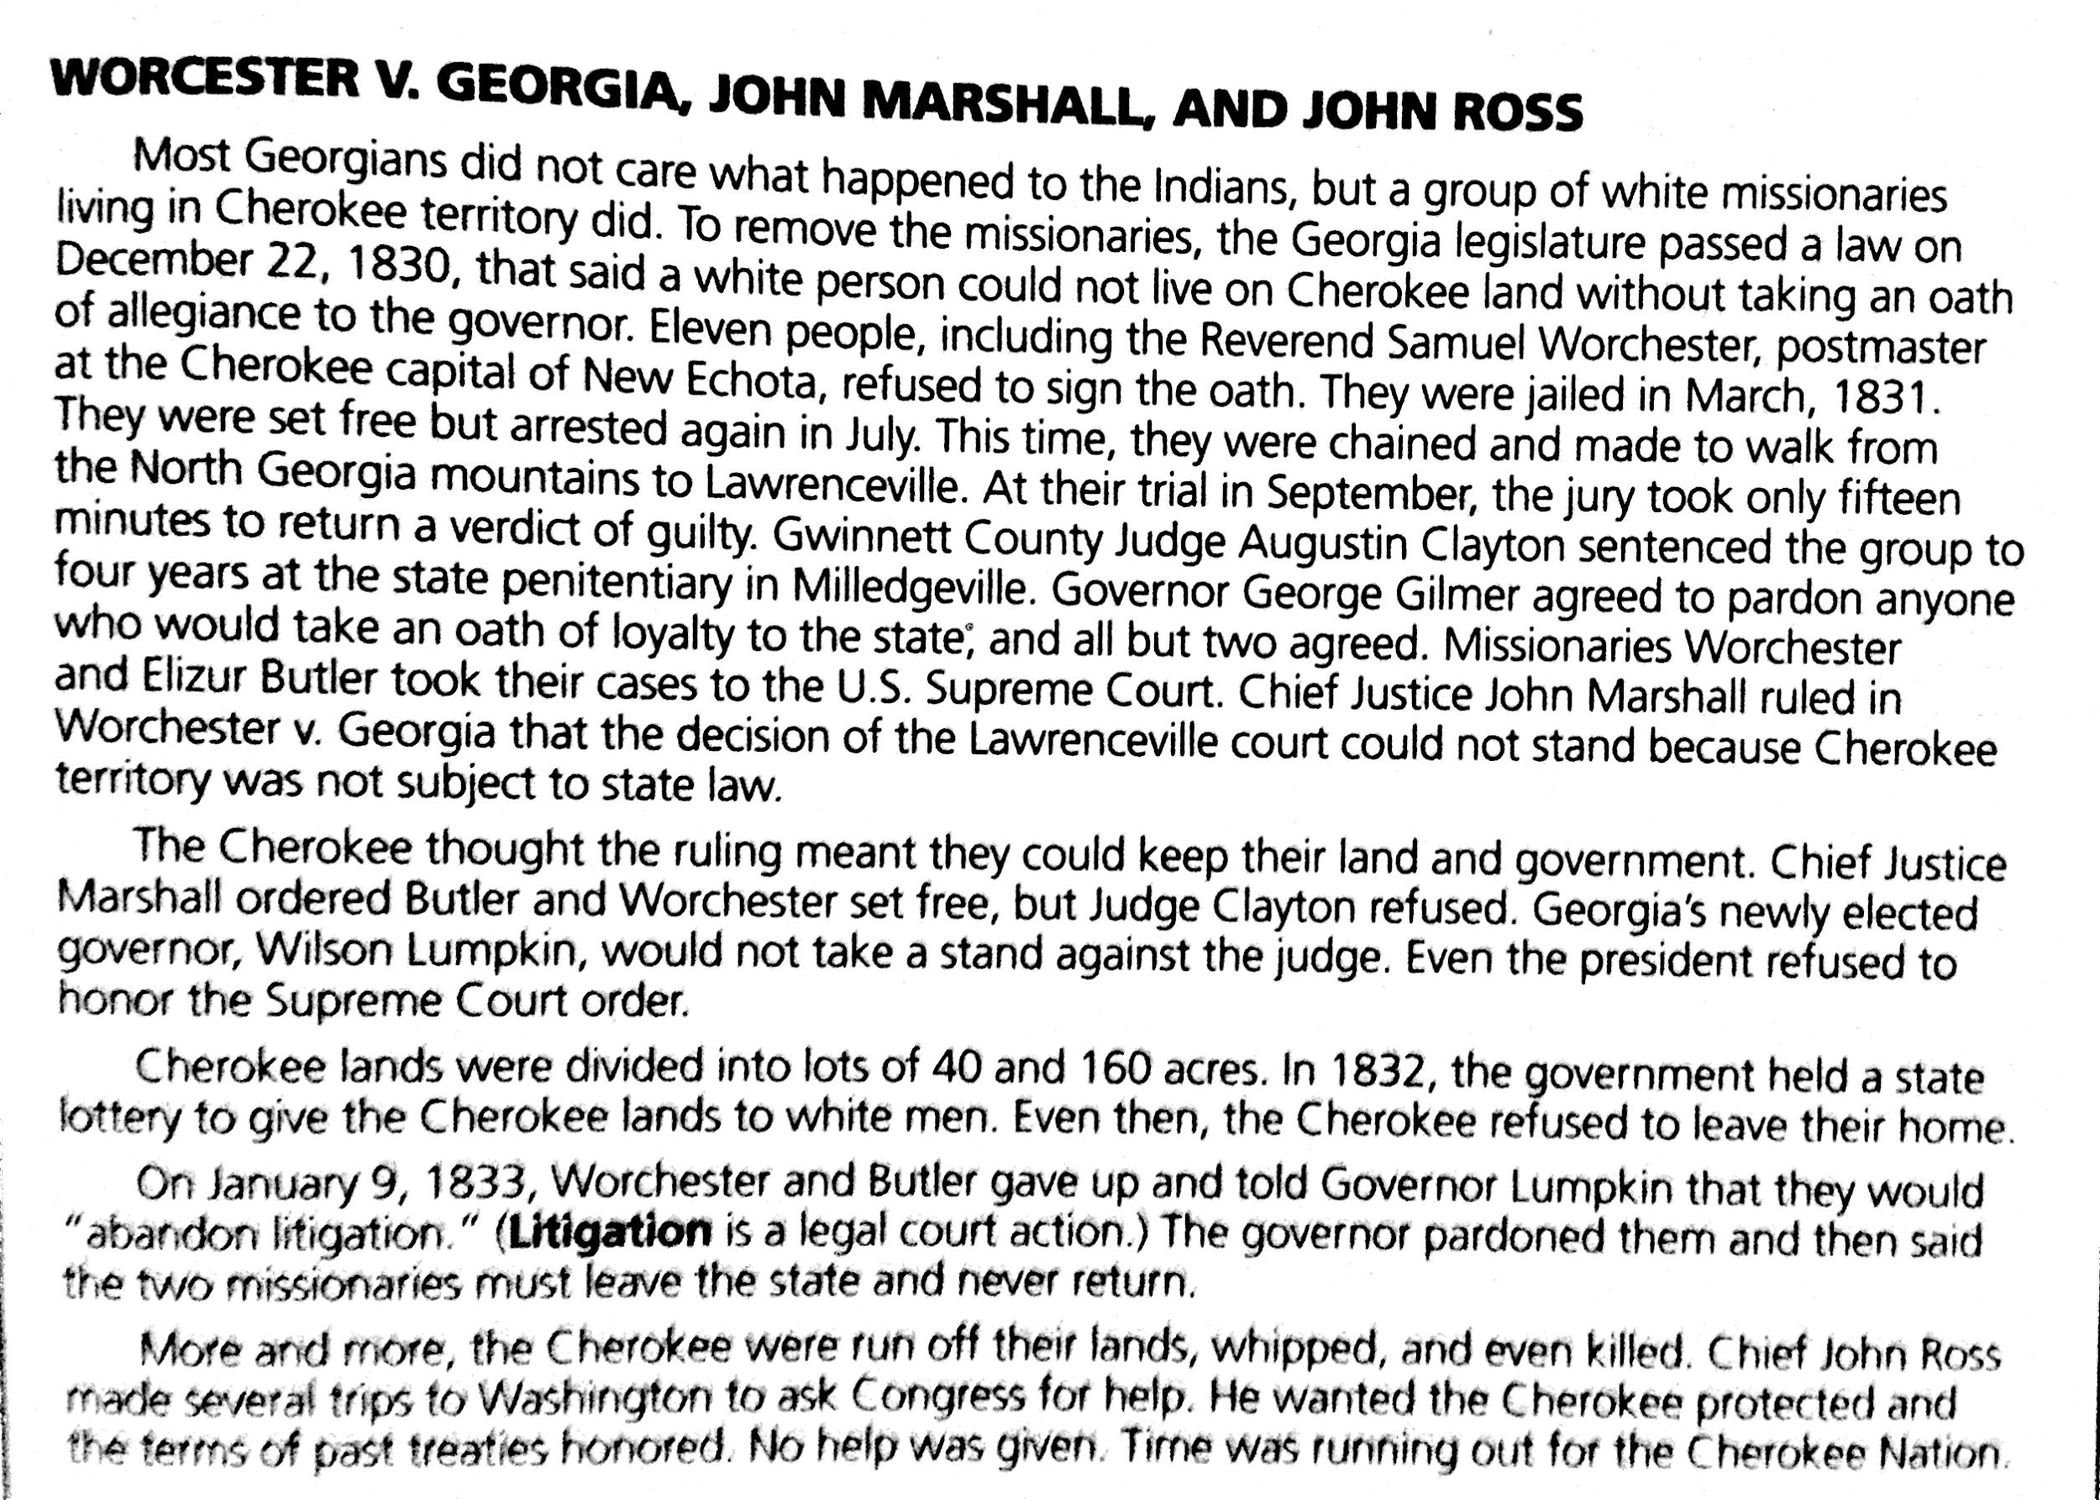

What did Worcester do to stand up for the Cherokee?

What was the ruling in the Worcester v GA case?
How did John Ross try to help the Cherokee?
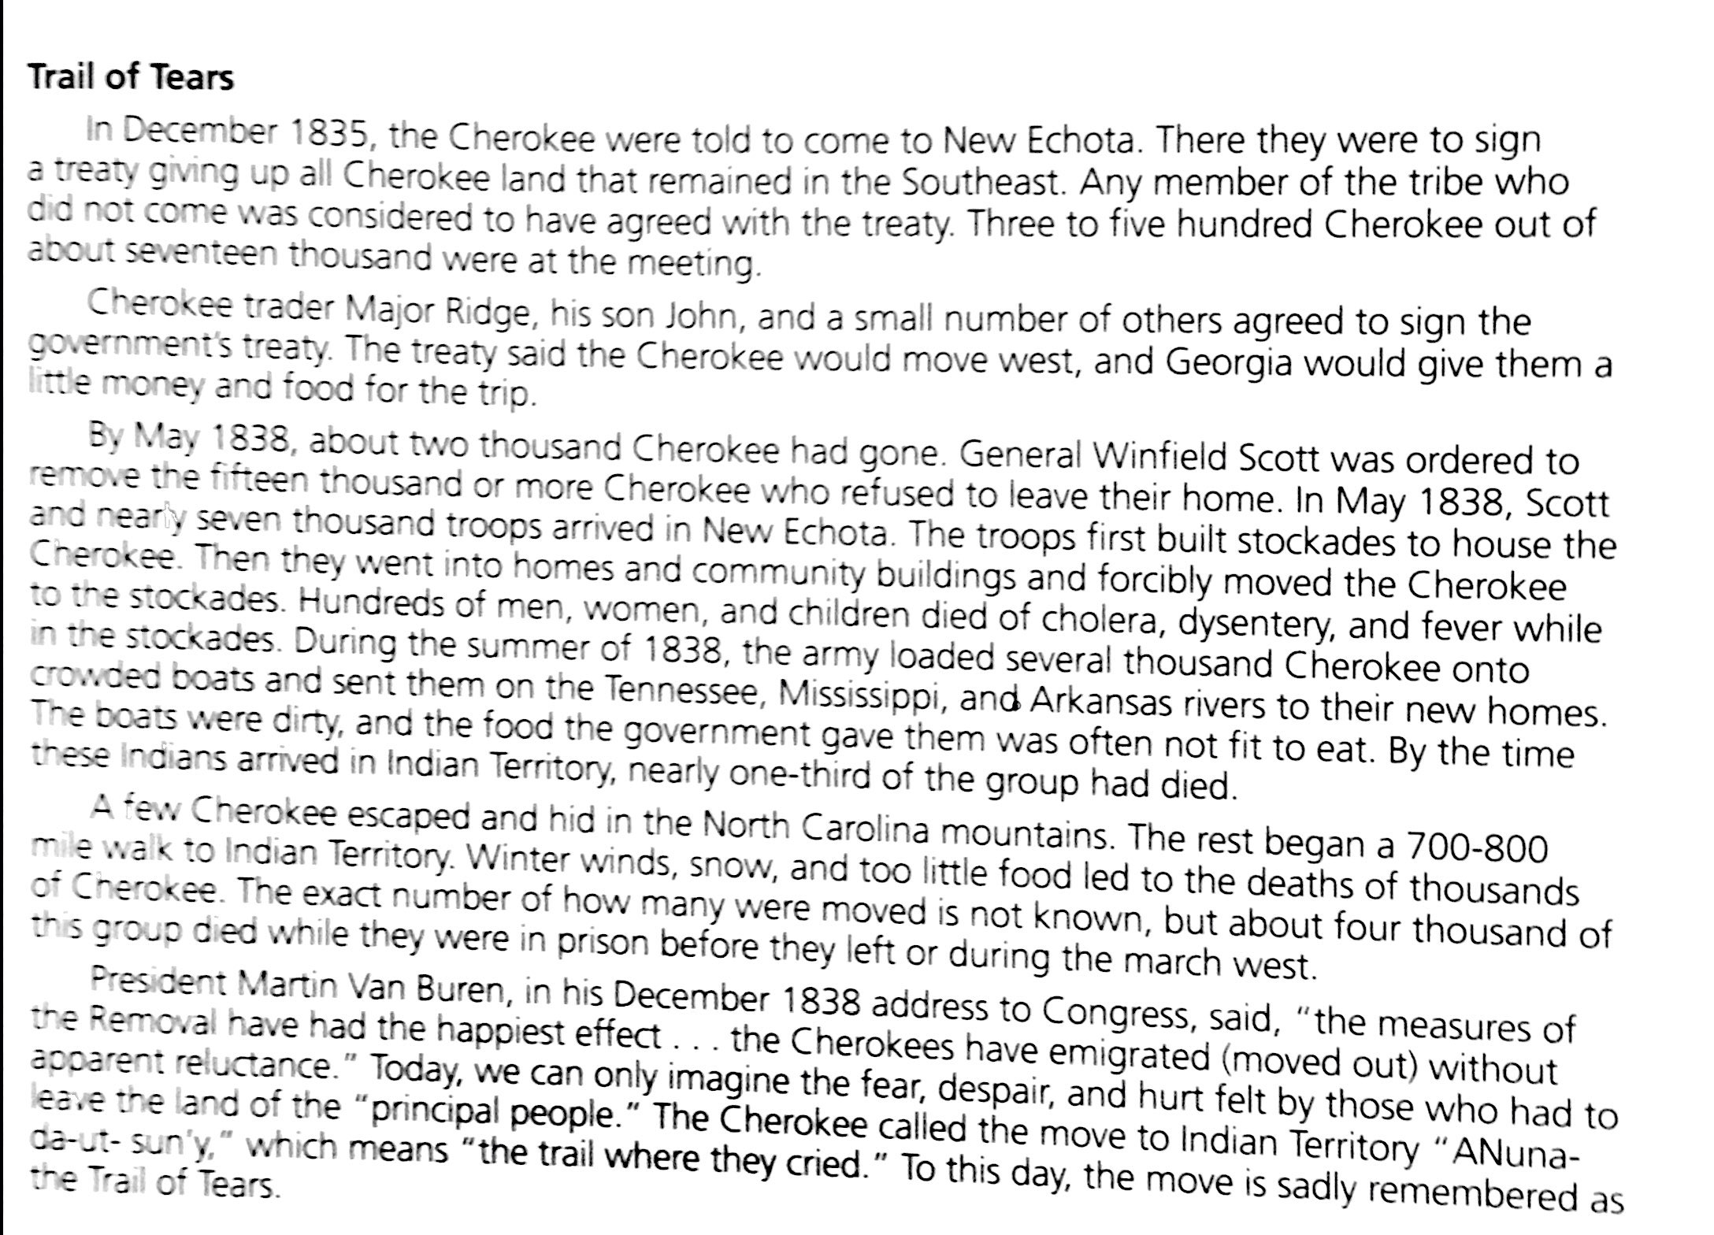

Where did the Cherokee sign the treaty giving up their lands?

How did the Cherokee migrate west?

What happened to many of the Cherokee on the journey?

