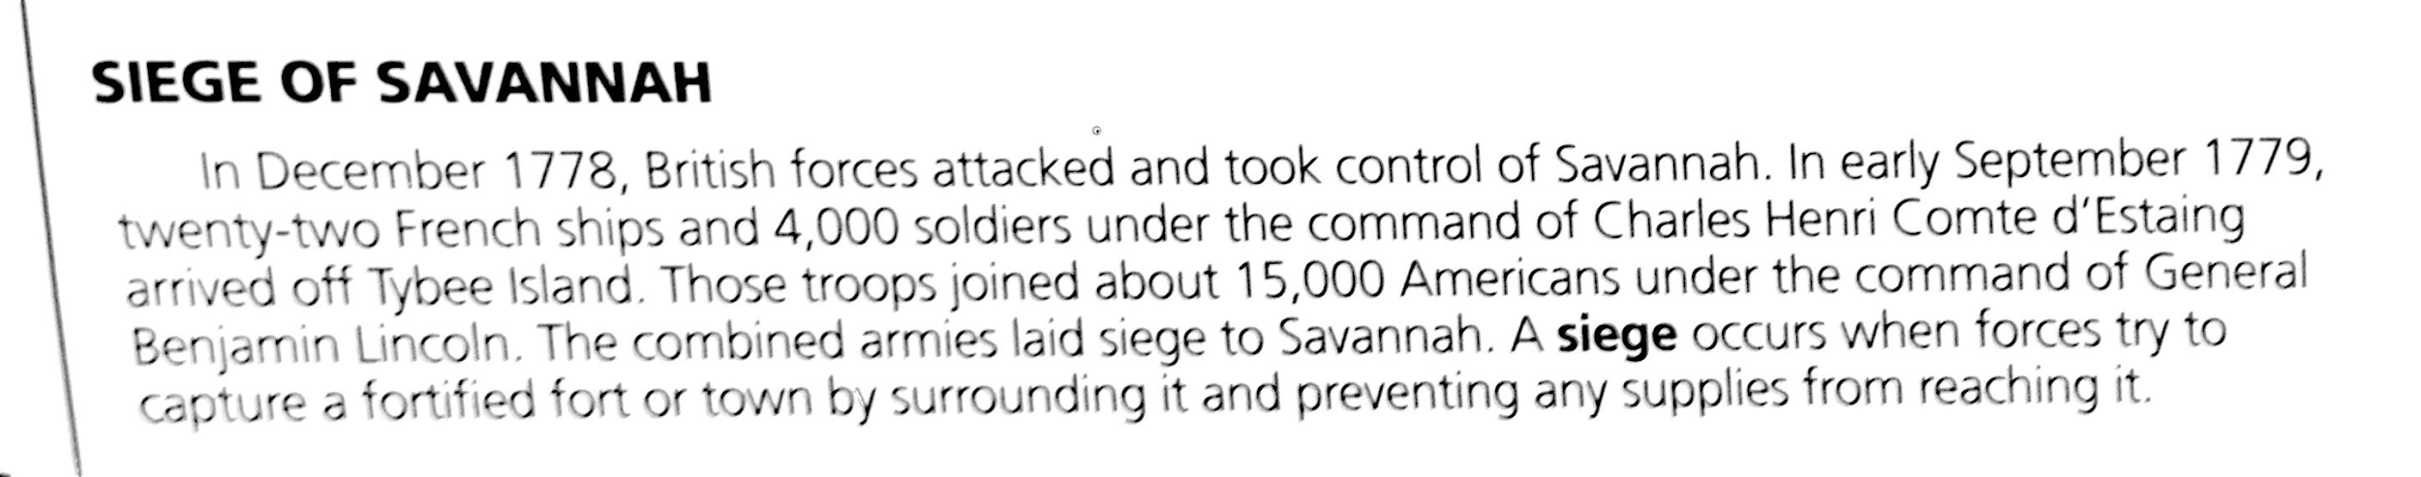

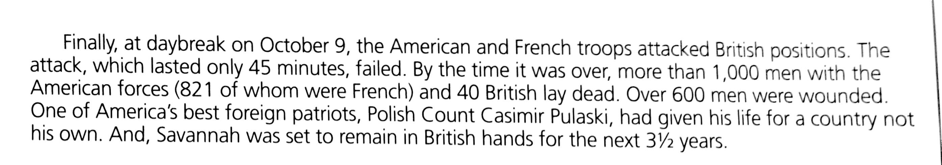

Who took control of Savannah in 1778?

Who attacked to take Savannah back?

Who was the hero of the Siege of Savannah?

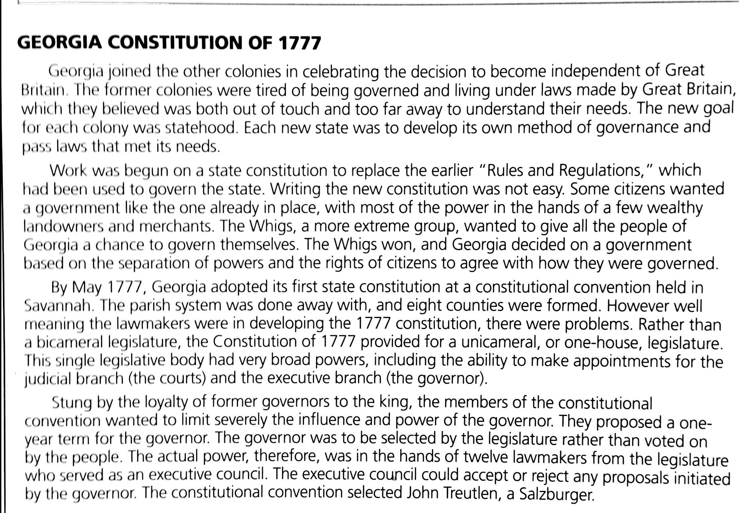

What was the GA constitution of 1777 replacing? What was the group who wrote it?

What were some problems of the Constitution of 1777?

How was the governor selected?
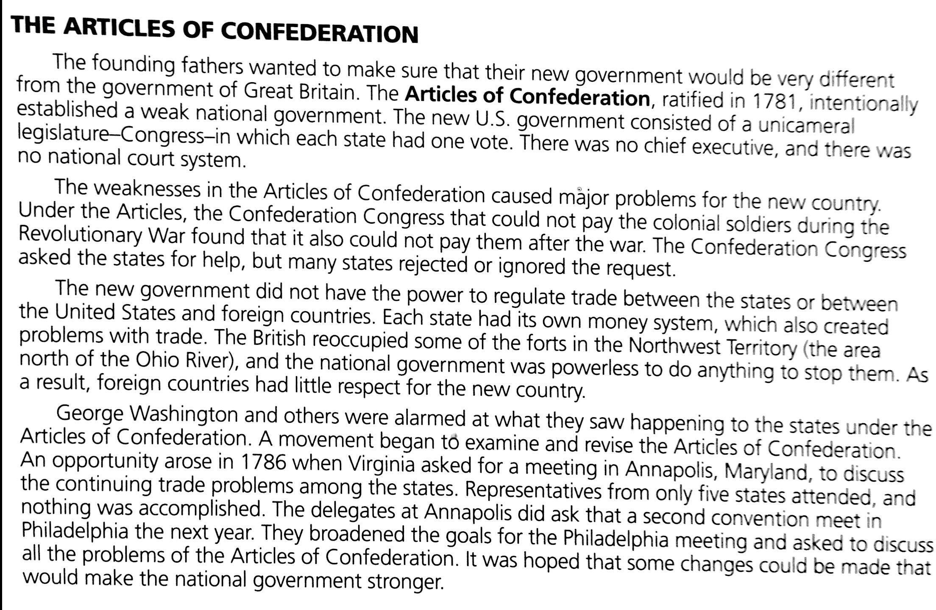

Describe the government created under the Articles of Confederation.

What problems did Congress face under the Articles?

Milestones #18-20

Siege of Savannah

Who took control of Savannah in 1778?

Who attacked to take Savannah back?

Who was the hero of the Siege of Savannah?

Georgia Constitution of 1777

What was the GA constitution of 1777 replacing? What was the group who wrote it?

What were some problems of the Constitution of 1777?

How was the governor selected?

Articles of Confederation

Describe the government created under the Articles of Confederation.

What problems did Congress face under the Articles?

