Photo #1
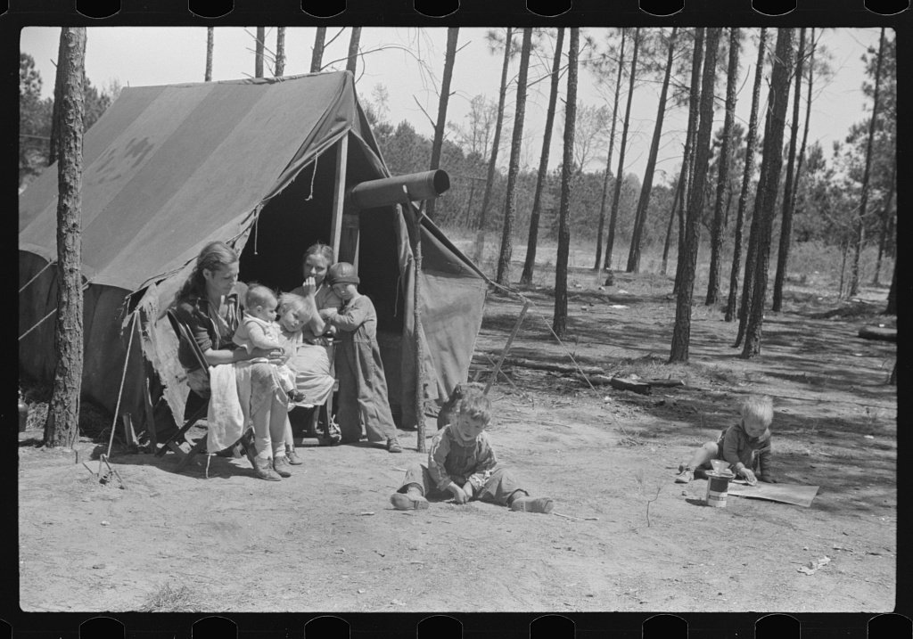

Caption (Original Description)
Home of one of two families who travel and work together all through the South, repairing stalls, stoves, tools, houses, and any other odd jobs. Tourist camp near Atlanta, Georgia

Photographer
Marion Post Wolcott

Created
1939

Location
Atlanta, Fulton, Georgia

Photo #2
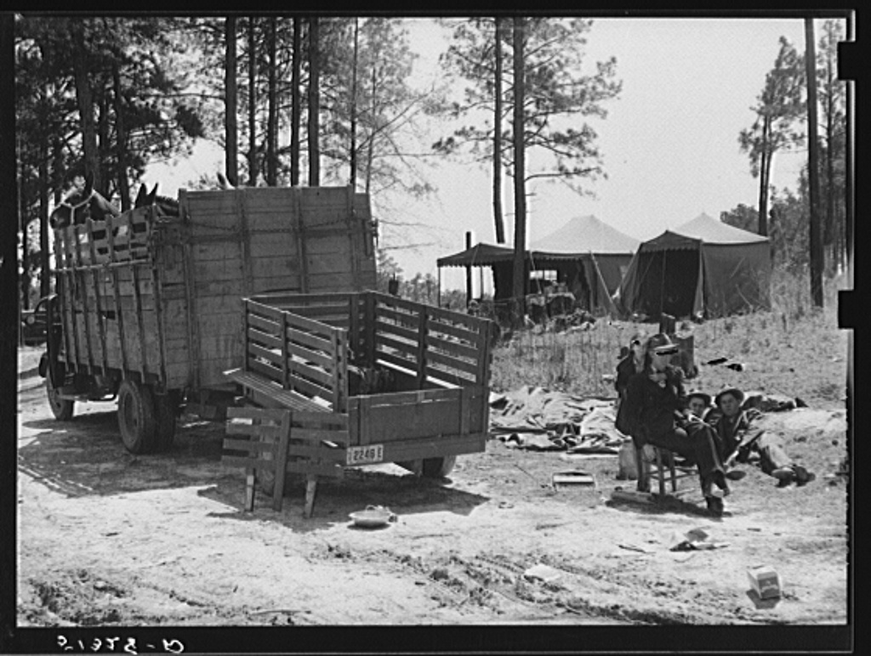

Caption (Original Description)
Atlanta mule warehouse sends a camp into rural sections of Georgia for several weeks at a time to sell mules to farmers

Photographer
Marion Post Wolcott

Created
May 1939

Location
Atlanta, Fulton, Georgia

Photo #3
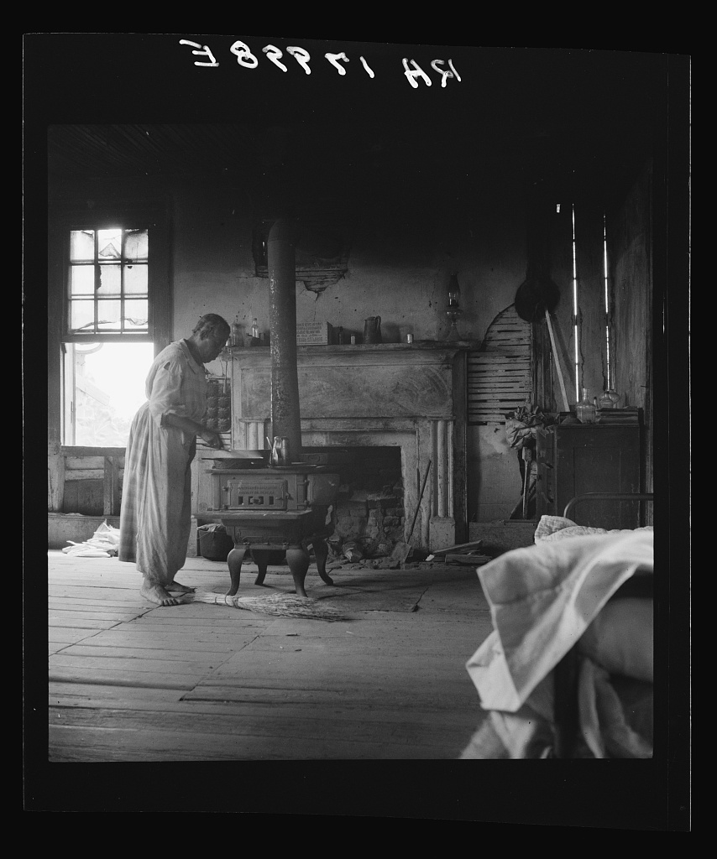

Caption (Original Description)
Interior of a plantation house now vacant but for two rooms occupied by an old Negro couple, tenants. Greene County, Georgia

Photographer
Dorothea Lange
Created
July 1937

Location
Greene, Georgia

Photo #4
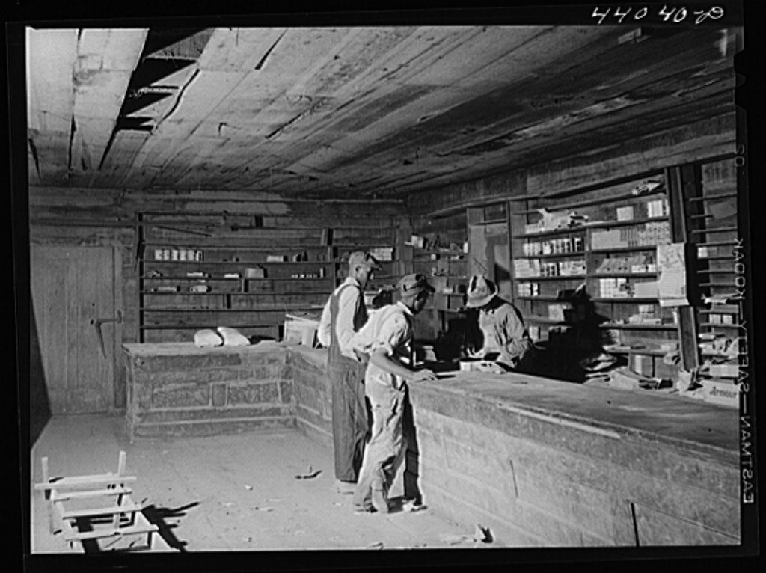

Caption (Original Description)
The remains of what used to be a prosperous store in the once-thriving community of Liberty Hill. Heard County, Georgia

Photographer
Jack Delano

Created
April 1941

Location
Liberty Hill, Lamar, Georgia

OBSERVATION...  What I See  - What people and objects do you see in this photograph?  - How are the people dressed?  - What is happening in this photograph?  - When was this photograph taken?  - Where was this photograph taken? What is the setting? | INTERPRETATION...  What I infer  - Why was this photograph taken?  - What is interesting or surprising about the photograph?  - What is unique about this image that the photographer wanted to capture?  - Does the photograph accurately reflect anything about a way of life during the Great Depression? Why?  - What can you conclude from what you see? | RESEARCH...  What I want to investigate  - Compose 2 research questions that need further investigation based on your observation and interpretation of this photograph.  NARRATIVE…  What I want to write about  - Choose ONE of the pictures you looked at. On a separate sheet of paper, write a paragraph narrative about what is happening in this chosen picture and how these people were affected by the Great Depression. Use your notes for information and details.

