Name: Due Date: December ___ at
the beginning of class
Georgia Battle Project
Project:
Students will create a poster on the Civil War battles that took place in Georgia. Students will include the following on the poster:
Battle name and year(s)
Cause and Effect summary
2-4 pictures (at least 2 should be drawings)
Georgia Map indicating where the battle took place
3-5 paragraph typed research paper on the battle

The research paper should include the following:
- Where the battle occurred (town, county)
- When the battle occurred (dates, year)
- Who was involved in the battle (famous people, important groups)
- Summary of events in the battle
- Who won the battle and why

Presentation:
Students will be asked to present their project to the class. During the student’s presentation, they will be asked to do the following:
- Present a summary of information on their battle
- Locate on the classroom map where the battle took place and explain what happened

Example of Poster:
Battle Name and Dates
Georgia Map
Cause/Effect Paper
Picture
Picture
Picture
Picture
Research Paper

Name: Grade:
CATEGORY | 4 | 3 | 2 | 1
Graphics/Pictures | Graphics go well with the text and there is a good mix of text and graphics. | Graphics go well with the text, but there are some pictures that are incomplete | Graphics go well with the text, but are poorly done or have no pictures. | Graphics do not go with the accompanying text or appear to be randomly chosen.
Attractiveness & Organization | The poster is well organized and contains the required components | The poster has some organization and contains the required components | The poster has minimal organization and/or may contain the required components | The pages formatting and organization of material are confusing to the reader.
Content - Accuracy | All facts on the pages are accurate and relate to the Georgia battle | 99-90% of the facts on the pages are accurate and relate to the Georgia battle | 89-80% of the facts on the pages are accurate and relate to the Georgia battle | Fewer than 80% of the facts on the pages are accurate and relate to the Georgia battle
Writing - Grammar | There are 0-1 grammatical mistakes on the pages. | There are 1-2 grammatical mistakes on the pages. | There are 3-5 grammatical mistakes on the pages. | There are several grammatical mistakes on the pages.
Listens to Other Presentations | Listens intently. Does not make distracting noises or movements. | Listens intently but has one distracting noise or movement. | Sometimes does not appear to be listening but is not distracting. | Sometimes does not appear to be listening and has distracting noises or movements.
Speaks Clearly | Speaks clearly and distinctly all (100-95%) the time, and stays on topic all (100%) of the time | Speaks clearly and distinctly all (100-95%) the time, and stays on topic most (99-90%) of the time. | Speaks clearly and distinctly most ( 94-85%) of the time and stays on topic some (89%-75%) of the time | Often mumbles or cannot be understood and it was hard to tell what the topic was.

Name: Grade:
CATEGORY | 4 | 3 | 2 | 1
Graphics/Pictures | Graphics go well with the text and there is a good mix of text and graphics. | Graphics go well with the text, but there are some pictures that are incomplete | Graphics go well with the text, but are poorly done or have no pictures. | Graphics do not go with the accompanying text or appear to be randomly chosen.
Attractiveness & Organization | The poster is well organized and contains the required components | The poster has some organization and contains the required components | The poster has minimal organization and/or may contain the required components | The pages formatting and organization of material are confusing to the reader.
Content - Accuracy | All facts on the pages are accurate and relate to the Georgia battle | 99-90% of the facts on the pages are accurate and relate to the Georgia battle | 89-80% of the facts on the pages are accurate and relate to the Georgia battle | Fewer than 80% of the facts on the pages are accurate and relate to the Georgia battle
Writing - Grammar | There are 0-1 grammatical mistakes on the pages. | There are 1-2 grammatical mistakes on the pages. | There are 3-5 grammatical mistakes on the pages. | There are several grammatical mistakes on the pages.
Listens to Other Presentations | Listens intently. Does not make distracting noises or movements. | Listens intently but has one distracting noise or movement. | Sometimes does not appear to be listening but is not distracting. | Sometimes does not appear to be listening and has distracting noises or movements.
Speaks Clearly | Speaks clearly and distinctly all (100-95%) the time, and stays on topic all (100%) of the time | Speaks clearly and distinctly all (100-95%) the time, and stays on topic most (99-90%) of the time. | Speaks clearly and distinctly most ( 94-85%) of the time and stays on topic some (89%-75%) of the time | Often mumbles or cannot be understood and it was hard to tell what the topic was.

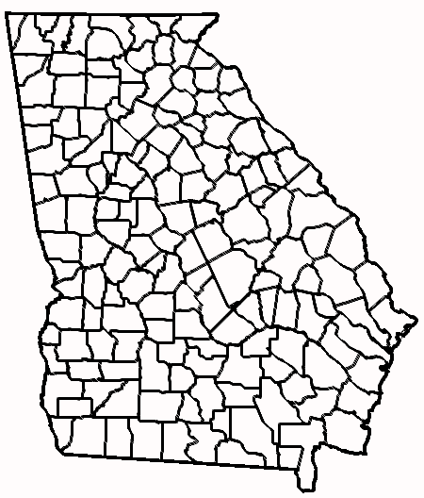
Cause Effect

Cause Effect

Civil War battles/encounters in Georgia

1. Andrews Raid

2. Battle of Chickamauga

3. Battle of Resaca

4. Battle of Pickett’s Mill

5. Battle of Kennesaw Mountain

6. Fall of Atlanta

7. March to the Sea

8. Wilson’s Raid

