Name: ________________________ Date: __________ Period: ____
Constitution

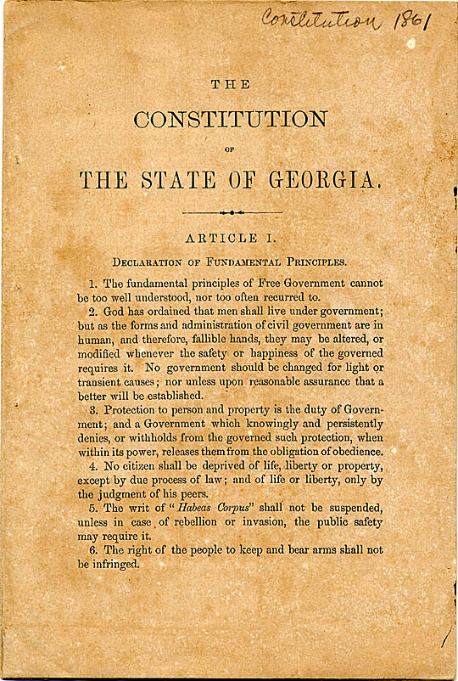
3. How many Constitutions in Georgia history? _____
4. Georgia’s First Constitution:
Ratified in 17___
5. Georgia’s Current Constitution:
Ratified in 19____
2. What does a state Constitution define?
________________________________________________________________________________________________
1. What is a Constitution?
________________________________________________________________________________________________
The Set Up

6. GA’s constitution is structured like the __________________.
7. How many Articles are in GA’s constitution? _____
8. What do the Articles do?
________________________________________________

PreAmble

9. What is a Preamble?
__________________________________________________________________
____________________________

Georgia’s Preamble:
- “To perpetuate the _______________________________________ , insure justice to all, preserve peace, promote the _______________________________________ and of the family, and transmit to posterity the enjoyment of liberty, we the people of Georgia, relying upon the protection and guidance of Almighty God, do ordain and establish this Constitution.”

Articles
11.
- Article I _______________________________________
- Article II _______________________________________
- Article III _______________________________________
- Article IV _______________________________________
- Article V _______________________________________
- Article VI _______________________________________
- Article VII _______________________________________
- Article VIII ______________________________________
- Article IX ________________________________________
- Article X _________________________________________
- Article XI _________________________________________

12. This Article contains:
__________________________________________________________________
____________________________
Article I

13. This Article states:
__________________________________________________________________
_____________________________
14. Rights
__________________________________________________________________
__________________________________________________________

Article X
15. Article X describes the _______________________________ Georgia’s Constitution.
The Constitution can be amended in two ways:
19. The second way is by ____________________________.
20. If two-thirds of each house of the General Assembly agrees to call such a convention, then delegates to the convention will meet to discuss and _______________________________________ to the constitution.
21. If the convention votes in favor of a proposed amendment, then the______________________________________ for a vote.

16. First, through ________________________________.
17. A state ___________ or ____________________ must introduce the proposed amendment and if __________________accept the change, then it goes before the people for a vote.
18. If the majority of voters ratify the amendment, it____________________________
22. It becomes part of the Constitution if a majority of the voters vote in _____________________________________________________.
Three Branches
- Like the government of the United States, Georgia’s government is divided into _______________________________________.
- Each branch has a _______________________________________, which is called _________________________________.

Checks and Balances
- So that one branch _______________________________________ , the branches put limits, or checks, on each other.
- If one branch makes an error, another branch can _______________________________________, or balance it.
- This system of limiting the roles of each branch and setting right another branch’s error is called _______________________________________.
Executive Branch
_________________________________________________________________________________________________________________________________________________________________________________________________________________________

Legislative Branch
_________________________________________________________________________________________________________________________________________________________________________________________________________________________
Judicial Branch
_________________________________________________________________________________________________________________________________________________________________________________________________________________________

Rights
- The US Constitution and the Georgia Constitution both give all _______________________________________ .
- Rights are standards that keep institutions from _______________________________________ .
- The Bill of Rights in Georgia’s Constitution _______________________________________ of the citizens:
- Right to _______________________________________ , right to keep and bear arms, right to trail by jury, right to a lawyer, etc.

Responsibilities
- Along with rights come ______________________________________ .
- Laws made by the government _______________________________________.
- As citizens, we have responsibilities to take care of ourselves, respect the rights of others, and _______________________________________

Qualifications
- Article II outlines the _______________________________________ for elections:
- You must be a _______________________________________ .
- You must be a _______________________________________ of Georgia and of the county where you wish to vote.
- You must be at least _______________________________________ of age.
- A person cannot vote if s/he is _______________________________________ for a felony conviction or has certain mental disabilities.
Elections
- Each fall, Georgians _______ for a number of positions, depending on the year.
General Assembly Elections:
- Every ___ years

Registration:
- Voters register to vote on a _____________________.
- Where do Georgia citizens vote? ________________________________________________

Governor and Lt. Governor
- Every ___ years

Absentee Ballots:
____________________________________________
County Government:
- Every _____ years, ____________ vote for ____________ in their county government.

Presidential Elections: _____________________________________________________________________________________________

Polling Places:
- Open from ____ to _____
- Employers are required to ________________________________________________

State Flag
- Georgia’s current state flag was adopted in _______ .
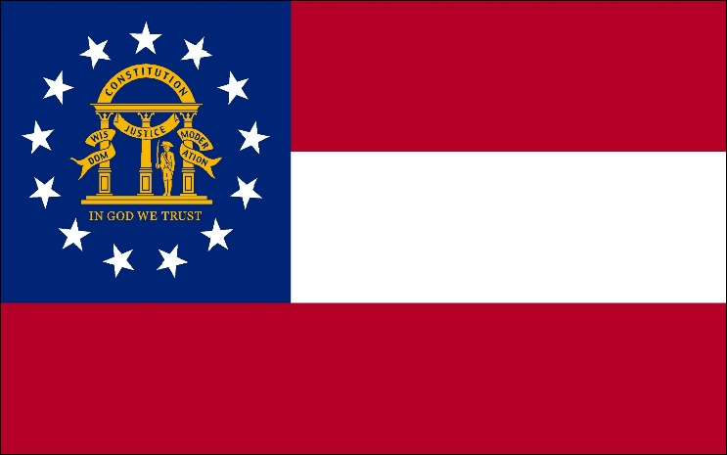
It has _______ red and white stripes and the ___________________
is in the upper left corner on a blue background.
The coat of arms has an _______________________________________ and three pillars that represent the ______________________________________________________________.

The words ______________________________________are wrapped around the pillars.

The Pledge
In 1935, the Georgia legislature adopted the Pledge of Allegiance to the Georgia Flag:
“I pledge allegiance to the Georgia flag and to the _______________________________________ Wisdom, Justice, and Moderation.”

The _______________________________________ of the Pledge of Allegiance are the same ones displayed on the coat of arms.

3 Principles
Moderation
__________________________________________________________________________________________
Wisdom
____________________________________________________________________________________
Justice
__________________________________________________________________________________________

