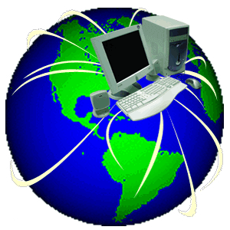
Current Events
Source Guidelines

Current is defined as occurring in or belonging to the present time. Therefore, you must follow the time guidelines below when selecting an article to use for your current events assignment.

Your article must come from a reputable news source. All of the sources listed below are acceptable. However, if you find an article from a source not listed below you must ask me first if it is acceptable to use for the assignment.

Most popular sources:

Source Name | Type | Within the last
abcnews.com | Online/Television News | 1 week
Boston Globe boston.com | Newspaper  Online version | 1 week
cbsnews.com | Online /Television News | 1 week
cnn.com | Online /Television News | 1 week
foxnews.com | Online Television News | 1 week
Atlanta Journal-Constitution (AJC)  AJC.com | Newspaper  Online version | 1 week
msnbc.com | Online /Television News | 1 week
National Geographic nationalgeographic.com | Magazine Online version | 1 year
Newsweek newsweek.com | Magazine Online version | 2 weeks
reuters.com | Online News Service | 1 week
Time  Time.com | Magazine Online version | 2 weeks
US News and World Report usnews.com | Magazine Online version | 2 weeks
USA Today usatoday.com | Newspaper  Online version | 1 week

Other acceptable sources include all other major newspapers/news magazines and their online versions~ Examples include but are not limited to:

Los Angeles Times New York Post Forbes Magazine
Chicago Tribune San Francisco Chronicle Associated Press
New York Times Washington Post

**You may use Google News as a search for articles, but Google News is not the source. Google News is simply a news search engine that gathers links to other newspapers or magazines. Whichever site it directs you to is the source.**

