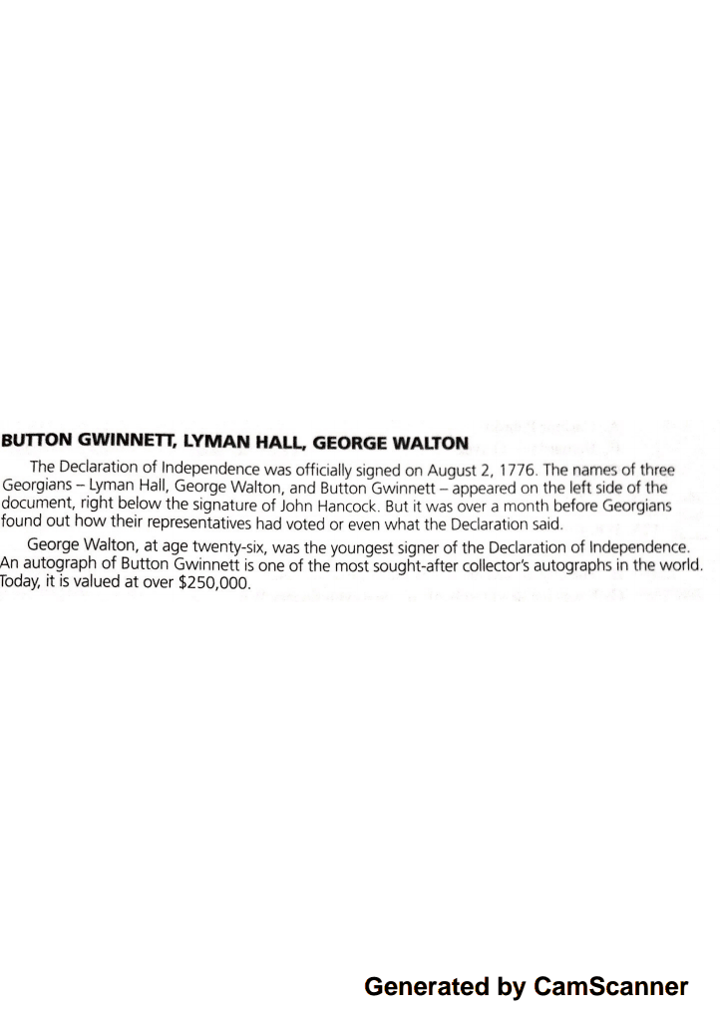
1. What were the names of the three Georgians who signed the Declaration of Independence?

2. In what year was the Declaration signed?

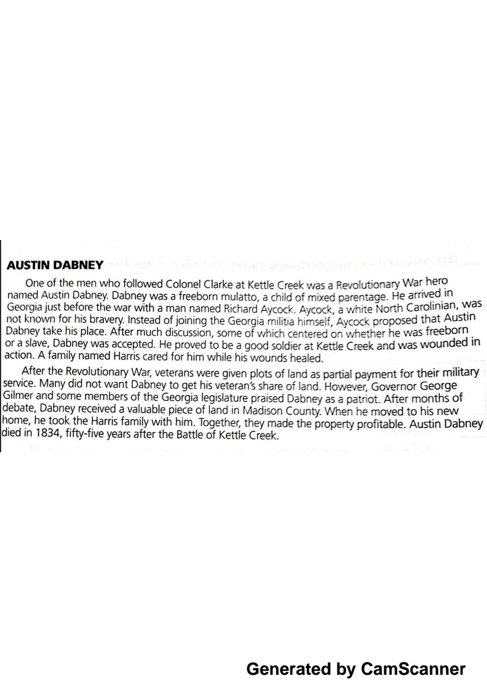

1. What battle did Austin Dabney become a war hero?

2. What happened to Dabney after the war?

