Name: _______________________________________________ Date: ___________ Period: _______
Andersonville – Virtual Field Trip
Directions: Go to the following link: http://www.gpb.org/education/georgia-studies/virtual-field-trips. Choose “Virtual Field Trip – Andersonville” by clicking on the picture. Next, click on the circle icon, “Andersonville.” Complete the questions below as you explore the site!
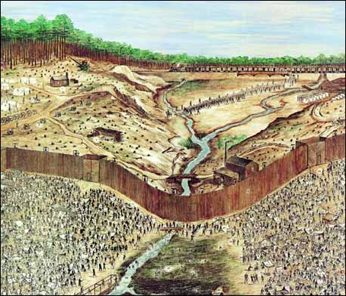
Andersonville:
- Why was Camp Sumter (the original name for Andersonville) built?

- During its 14-month operation, how many soldiers were imprisoned, and how many perished?

Click on the video icon at the top right-hand corner to answer the following questions:
- Why was the site for Camp Sumter chosen?

- When prisoners first began arriving in 1864, what was one of the very first downfalls of Andersonville?

Click on the “more” icon at the bottom right-hand corner to continue….
A - Stockade and Deadline:
- What would happen if a prisoner crossed “No Man’s Land”?

Hit “more” at the bottom of the screen to watch the video and answer the following:
- What did they call the line to protect the stockade walls?

- How many prisoners was the camp built to hold? How many prisoners did it hold at the height of its operation?

- What were some of the problems with the stream?

B - Star Fort:
- What was the Star Fort used for? ---
Hit “more” at the bottom of the screen to watch the video and answer the following:

- Who was put in charge of discipline within Andersonville prison?

- What was one of the thing Capt. Henry Wirz did that resulted in his execution?

- Where did prison supplies come from?

C - Reconstructed Prison Site:
- What items did the prisoners use to construct their shelters?

Hit “more” at the bottom of the screen to watch the video and answer the following:
- If prisoners didn’t have any items to build a shelter, what else would they do?
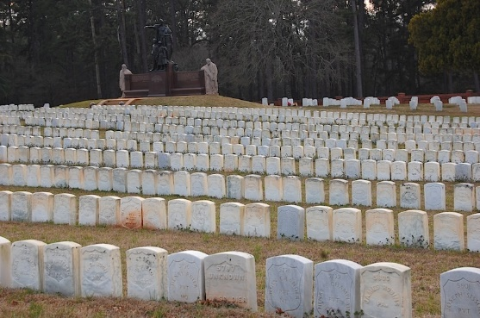
- Name 3 diseases the prisoners died from:

- How did some prisoners escape Andersonville?

D - Cemetery:
- Some 13,000 men died at Andersonville from ________________________, _________________________, __________________________________, __________________________, and ________________________.

Hit “more” at the bottom of the screen to watch the video and answer the following:

- How were soldiers buried once they ran out of materials for coffins?

E – Raiders Graves:
- Who were the Raiders?

- What eventually happened to the 6 ringleaders?

- Describe what happened to the other gang members after the trial:

